# Practical Help Desk

## 1.Course Introduction

## 2.Intro to IT

IT – all technological work at a company ( for this course we’ll focus more on the traditional IT dept definition like including a wide range of hardware and software )

Excluding things like software development and engineering

IT dept play a huge role in managing and supporting technology required for org to function

IT dept responsibilities ( general )

* Infrastructure management
* Tech Support
* Security
* Data Management
* Identity and Access Management
* Project Management
* Compliance and Governance

It doesn’t have to be a company providing a technical solution / software product , even a law firm – could involve use of computers / devices . So, the role of IT can be very general and apply to all types of sectors.

IT dept Org Chart ( No 2 orgs/IT are same – size/role/industry/budget can differ , job titles are generalizations – JD gives better idea to judge job titles )

(e.g.) for Medium to Large business

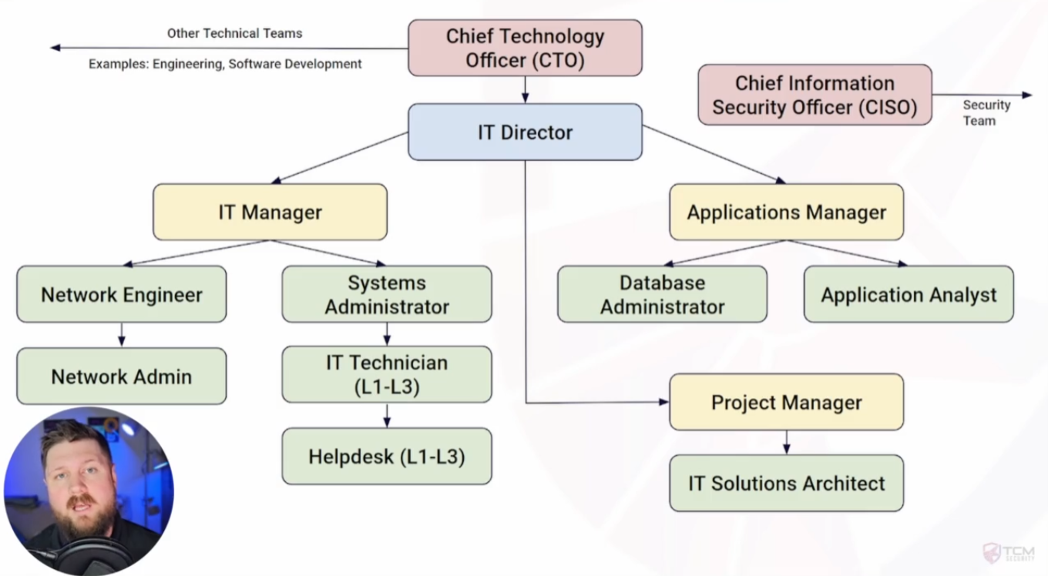

### IT Department Roles

CTO (Chief Technical Officer) – executive position responsible for overseeing technological direction of an organization

IT Director – Senior Management position responsible for overseeing IT operations and ensuring they align with business goals

IT Manager – Management Position responsible for overseeing a team of IT professionals , can vary depending on team(s)

Network Engineer – Individual contributor responsible for designing , monitoring and maintaining an organization’s computer networks

Network Administrator – Individual contributor responsible for maintaining and monitoring an organization’s network

Systems Administrator – Individual contributor responsible for managing and monitoring an organization’s infrastructure ( usually excluding network )

IT Technician – Individual contributor responsible for supporting , installing and configuring infrastructure and software

Applications Manager – Manager responsible for overseeing management , installing and support for software applications in an organization

Database Administrator – Individual contributor responsible for administrator , configuration and support of an organization’s databases

Application Analyst – Individual contributor responsible for configuration and support of software applications

Project Manager – Responsible for planning and overseeing IT projects such as deployment of a new application or infrastructure

Solutions Architect – Responsible for high level design and oversight of IT solutions

**Leadership & Strategy (The "Why")**

* **CTO:** The visionary. Sets the long-term *technology strategy* for the entire company.
* **IT Director:** The department head. Manages the budget and aligns IT *operations* with business goals.
* **IT / Applications Manager:** The team boss. Oversees a specific group's daily work and projects.

**Design & Projects (The "What & When")**

* **Solutions Architect:** The designer. Creates the high-level *technical plan* for a solution.
* **Project Manager:** The organizer. Runs projects on *time* and on *budget*.

**Technical Specialists (The "How")**

* **Network Engineer:** *Designs and builds* the network (routers, firewalls).
* **Network Administrator:** *Maintains and monitors* the network daily.
* **Systems Administrator:** Manages *servers* and core infrastructure (not network).
* **Database Administrator (DBA):** Manages, secures, and optimizes *databases*.
* **Application Analyst:** Configures, supports, and troubleshoots specific *software applications*.

**Support (The "Fix-It")**

* **IT Technician:** The first responder. Solves day-to-day *user issues* with hardware and software.

### Help desk roles and responsibilities

Help Desk – individual contributor responsible for providing technical support and assistance to end users , either within an organization or to customers

* Front-line technical support to end users
* Troubleshoot hardware , software , network and other issues
* Password and account management
* Customer Service
* Escalation of support to appropriate people or channels
* Fixing or installing hardware
* Installing or configuring software
* Maintain and create documentation

## 3.Intro to Computing

### The binary system

Decimal -> Base 10 -> 0,1,2,3,4,5,6,7,8,9 (10 nos )

163 = 1*10^2 + 6*10^1 + 3*10^0 = 100 + 60 + 3 = 163

Binary -> Base 2 -> 0,1 ( 2 nos )

10100011 = 1*2^7 + 1*2^5 + 1*2^1 + 1*2^0 = 128 + 32 + 2 + 1 = 163

Hexadecimal -> Base 16 -> 1,2,3,4,5,6,7,8,9,A,B,C,D,E,F ( 16 nos )

A3 = 10*16^1 + 3*16^0 = 160 + 3 = 163

**(0xA3)** - 0x is just a prefix, not part of the number itself — it’s a signal that the number is in base 16

Extras:-

Octal -> Base 8 -> 1,2,3,4,5,6,7,8 (8 nos)

243 = 2*8^2 + 4*8^1 + 3*8^0 = 128 + 32 + 3 = 163

### Bits and Bytes

1010 0011 ( single digit called bit , 4 bits called nibble and 8 bits called byte )

Encoding – Representing info ( text ,image ,sound ) as numbers

**1. Text Encoding**

* **ASCII** → Maps characters to numbers (e.g., A=65, C=67).
* Numbers are then stored in **binary** (C = 67 = 01000011).
* **Unicode** → Modern encoding covering all languages + emojis.

**2. Image Encoding**

* Images = grid of **pixels**.
* Each pixel has **RGB values (0–255 each)**.
  + Red = (255,0,0)
  + White = (255,255,255)
  + Black = (0,0,0)

**3. Video Encoding**

* Video = sequence of images (**frames**) shown quickly (e.g., 30 fps).
* Adds **time dimension** to images.
* Uses compression (e.g., MPEG, H.264) to reduce size.

**4. Audio Encoding**

* Sound = sampled as numbers (e.g., 44,100 samples/sec).
* Stored as formats like MP3, WAV.

* Hex/Octal are just **ways to write numbers**.
* ASCII/Unicode are **dictionaries that assign meanings to those numbers**.(65=A according to ASCII)

### How a Computer Works

**🔹 1. Transistor: the building block**

* Tiny **electronic switch** → ON (1) / OFF (0)
* Core of **all digital circuits**
* Combines to form **logic gates**: AND, OR, NOT, XOR → perform calculations

**🔹 2. Basic arithmetic with transistors**

* **Addition example:** 4-bit adder:
  + 4 full adders → ~120 transistors
  + Each bit = 1 full adder → handles sum + carry
* **Multiplication:**
  + More complex → partial products + multiple adders → ~200+ transistors for 4-bit multiply
* **Division/floating-point** → even more transistors → most complex in CPU

**🔹 3. Storing data**

* **1 bit = flip-flop / latch** → 2–6 transistors per bit
* Thousands of transistors → can store KBs → millions → GBs
* **Memory scaling:** SRAM → DRAM → modern chips

**🔹 4. Integrated Circuits (ICs)**

* Invented 1958–1960 → Jack Kilby & Robert Noyce
* Put **many transistors on a single silicon chip**
* Allowed **miniaturization** → calculators → computers → modern CPUs & memory

**🔹 5. Evolution**

* **Early circuits:** discrete transistors → huge boards → limited memory
* **1960s–1970s:** small ICs → KB memory, calculators
* **1980s–1990s:** millions of transistors → CPUs, MB memory
* **Today:** billions of transistors → modern processors, GPUs, huge RAM
* Everything = **transistors turning ON/OFF in patterns** → numbers, text, images, video, audio

💡 **Takeaway:**

* **Transistors = ON/OFF switches**
* **Logic gates → arithmetic → memory → ICs → modern computers**
* At the hardware level, **all complex operations boil down to billions of tiny switches working together**

So, the **instruction set tells the CPU what operations it *can* do**, and

the **registers are where it keeps the immediate data it’s working on while doing those operations**.

### Compilers and Abstraction

* **CPU understands only binary (machine code)** → instructions like add, load, jump (defined by ISA)
* **High-level code (C, Java, Python)** → **Compiler** → usually generates **assembly code** (mnemonics)
* **Assembly code** → **Assembler** → machine code (binary CPU can execute)
* **Interpreter / JIT** → generate machine code at runtime
* **Machine code** stored in executable (e.g., paint.exe) → OS loads it → CPU executes

💡 **Flow:**  
Programmer → High-level code → Compiler → **Assembly code** → Assembler → Machine code → OS loader → CPU executes

**Note:**

* Assembly is an **intermediate, human-readable step** between high-level code and machine code.
* CPU never sees assembly — it only executes **machine code**.

**Abstraction** - Hiding the complex details of how something works and exposing only what you **need to use**.

## 4.Desktop Computer Components and Repair

### Section Intro

• Monitor = **output only**, no storing or processing.

• All storage is done in **RAM, cache, or disk**, managed by the CPU.

**External Monitors for Laptops vs Separate Desktop PCs**

1. **Laptop + external monitor:**
   * The **CPU, GPU, RAM, and storage are all inside the laptop**.
   * The external monitor is just a **display output**.
   * You’re not adding processing power — only a bigger/multiple screen for **multitasking**.
2. **Desktop PC + monitor:**
   * The CPU, GPU, RAM, and storage are in the desktop tower.
   * The monitor just receives video output.
   * Functionally similar to laptop + monitor, but desktop components are usually **more powerful** and upgradeable.

💡 **Key point:**

* Using an external monitor **doesn’t change performance**; it just improves **usability and multitasking**.
* The main difference between laptops and desktops is **where the CPU/GPU/ram are located** and **how upgradeable they are**.

**Lenovo ThinkPad**

* Very common in enterprises.
* Often **leased** by organizations to reduce cost of bulk purchases and cover risks like spills or theft.
* Instructor’s case: bought a refurbished unit for **$200**.

### ESD ( electro static discharge ) precautions and opening computers

ESD mat and wires to connect wrist band to earth either to a conducting surface or a earth pin

Special bags to prevent ESD to keep electronic components inside – useful for shipping without risk of ESD

Try to always hold PCBs at the end and do not touch ICs directly , use a plastic to point to it

### The Central Processing Unit (CPU)

The green part is the motherboard – we’ll talk later on it

CPU generally behind a cooling mechanism ( heat sink and a fan )

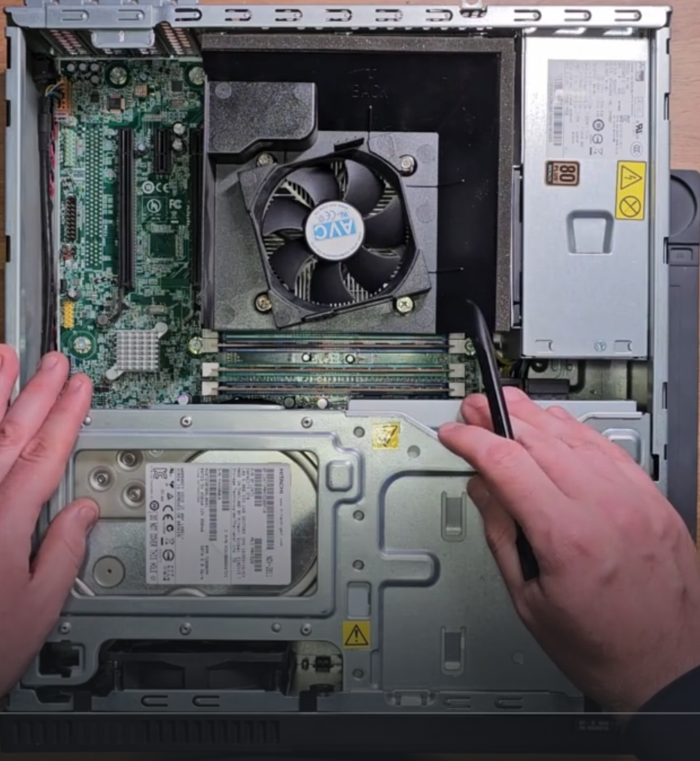

Well after removing the fan , we see the CPU at the centre of the motherboard

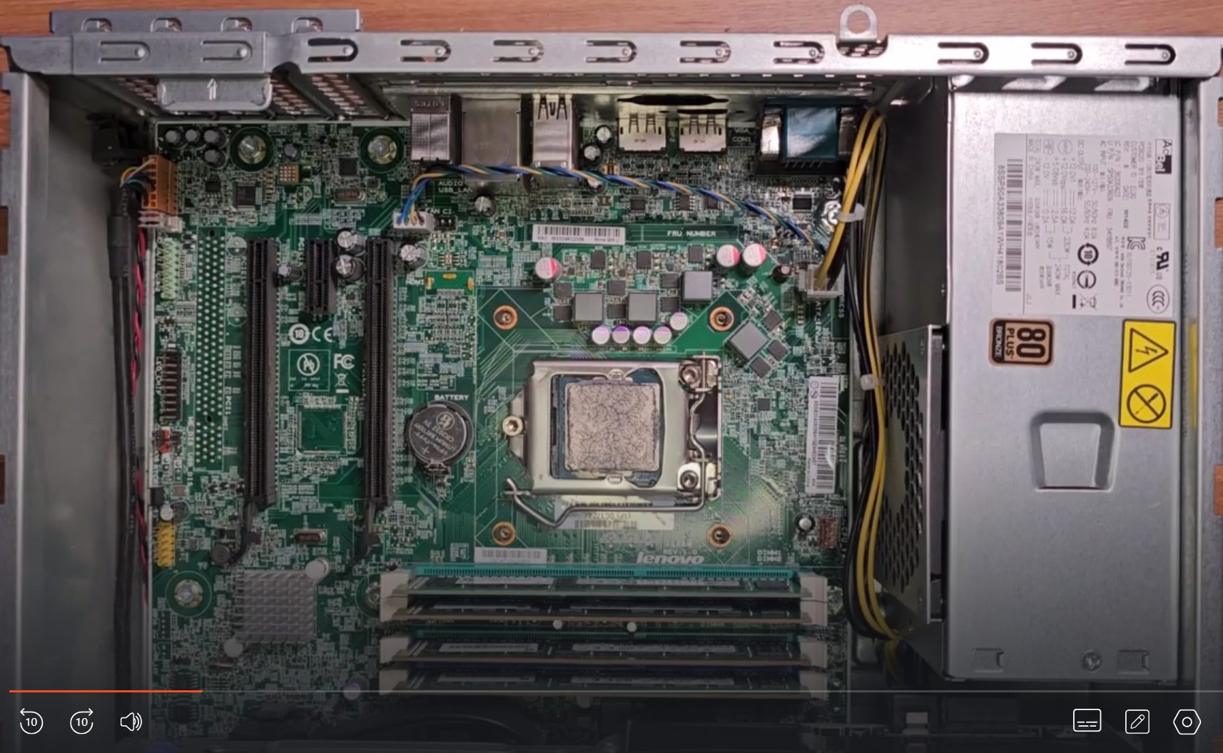

We have a thermal paste(high heat conductivity) on top of the CPU to dissipate heat

For desktop computers generally we see intel or AMD

According to the specific model no of the CPU

**Specs to check:**

* **Cores / Threads** → more cores = better multitasking.
* **Processor frequency (GHz)** → higher frequency = faster per-core performance.

Next for COMPATIBILITY we check SOCKETS supported e.g. FCLGA1150 ( sometimes called LGA)

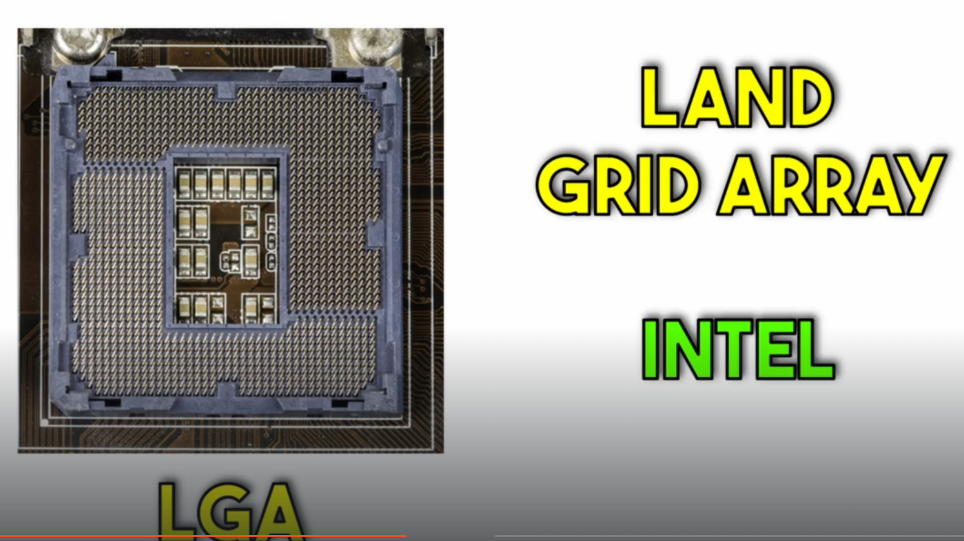

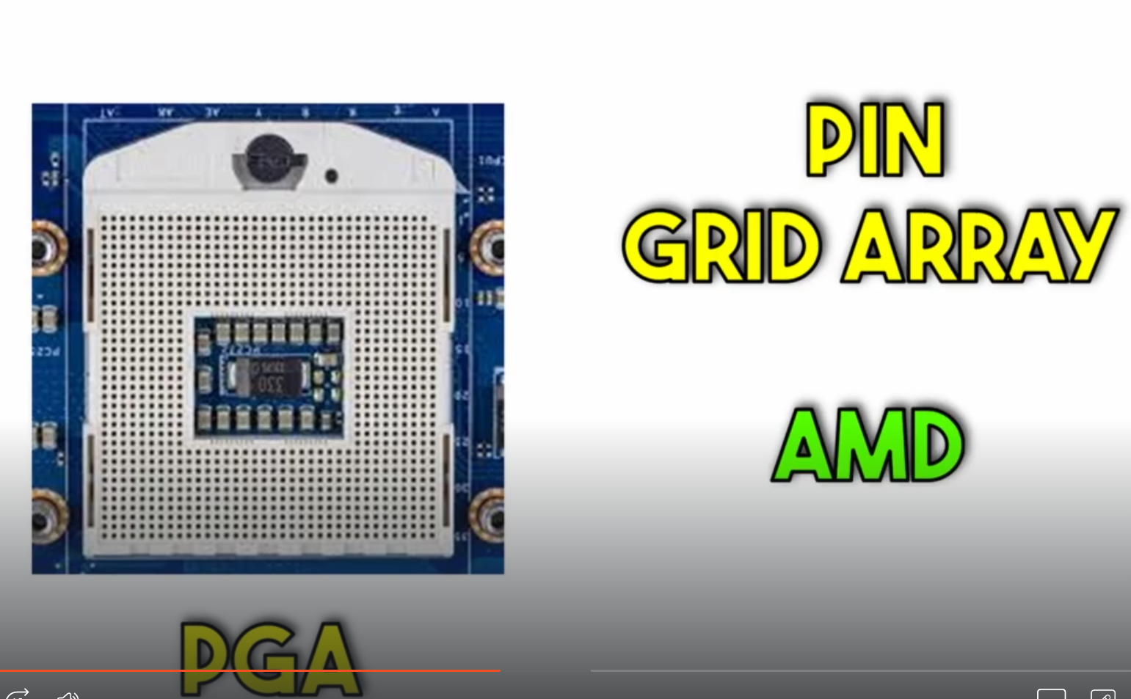

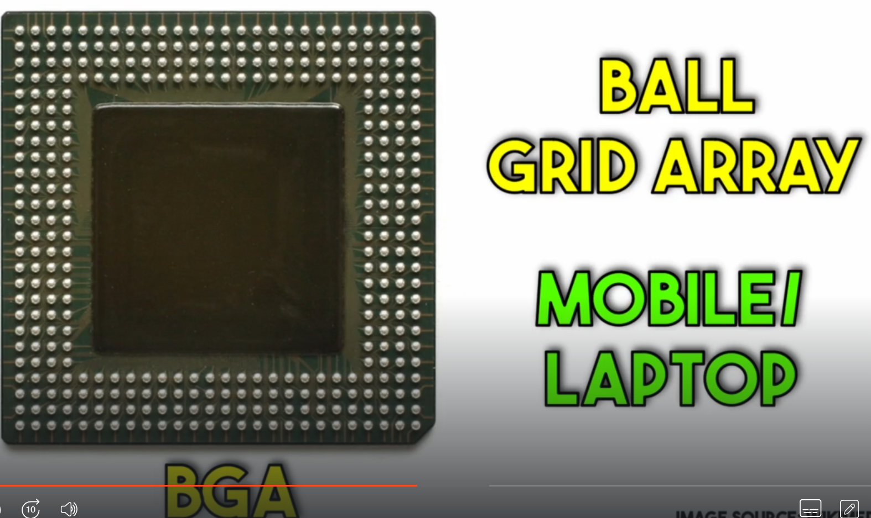

Much more difficult to replace as it is soldered

**Installing / Reinstalling a CPU**

1. Place CPU into the correct socket (align pins/markers).
2. Apply a thin layer of **thermal paste** on top.
3. Spread evenly (spatula is usually provided).
4. Mount and secure the **CPU cooler**.

### Random Access Memory (RAM)

4 RAM sticks according to this

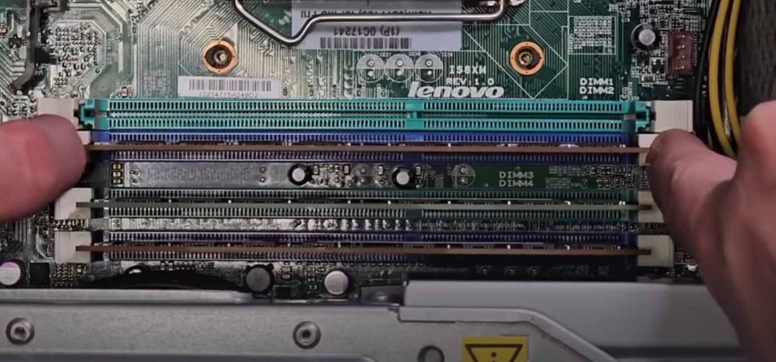

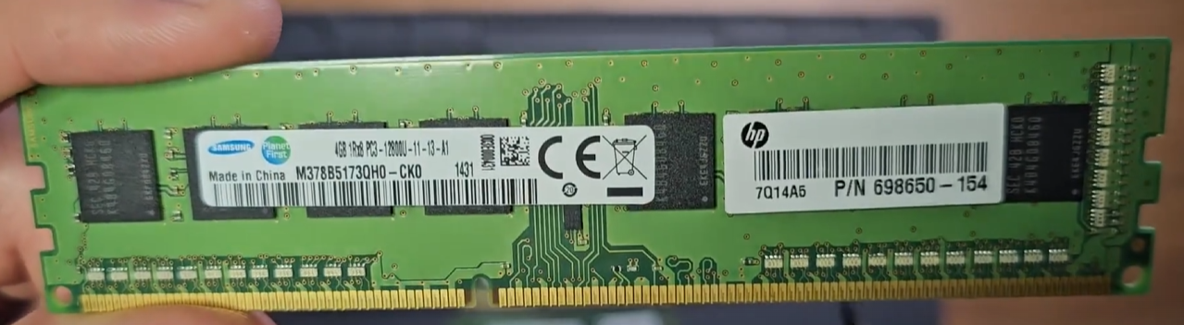

Manufacturer – Samsung

4GB (capacity of RAM stick )

PC3/DDR3 – type of RAM

12800 (12.8GB/sec) Bandwidth/speed of the RAM

Always prefer to use identical ( of same manufacturer ) RAM sticks to use

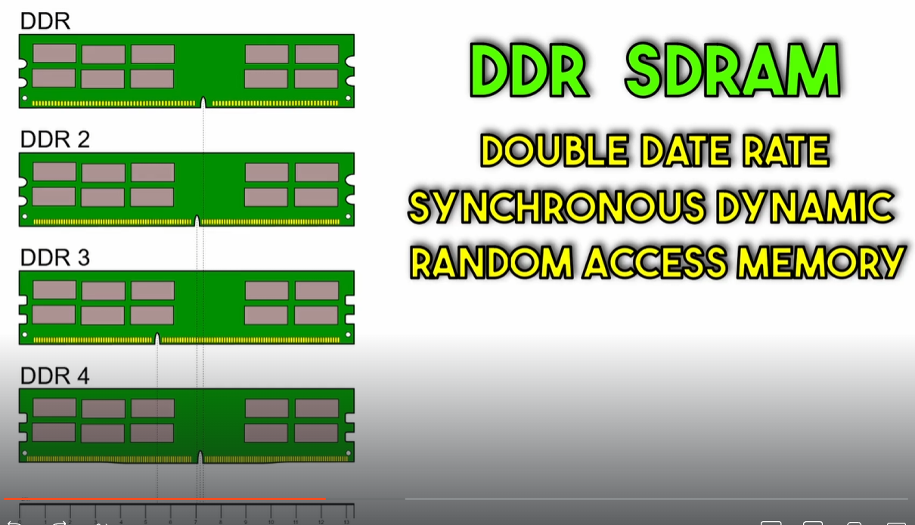

### Drives

Older ones have Disk drives ( with a SATA and power supply connectors )

And a HDD and SSD (smaller one)

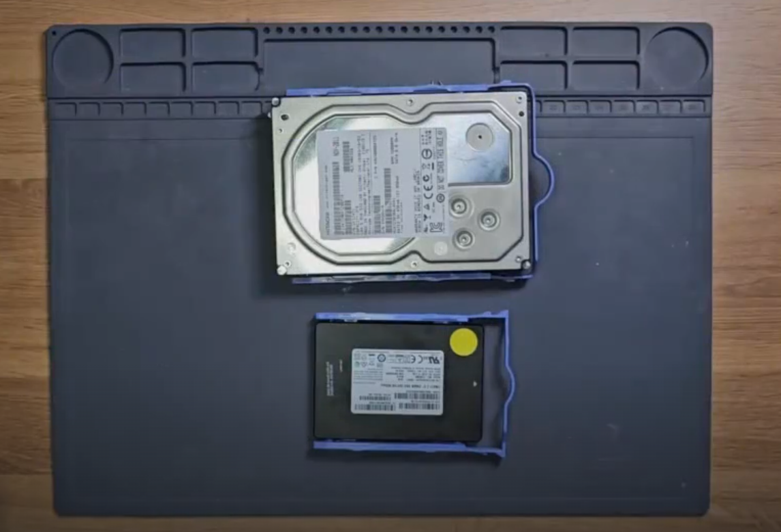

HDDs are cheaper and have a high storage capacity compared to SSDs , and have moving parts to read and write – making them slower

SSDs are solid state drives making them non movable parts , more expensive also less in storage but have a quick read and write operations – making it suitable for storing OS and other frequently accessed applications

### Power Supply Unit (PSU)

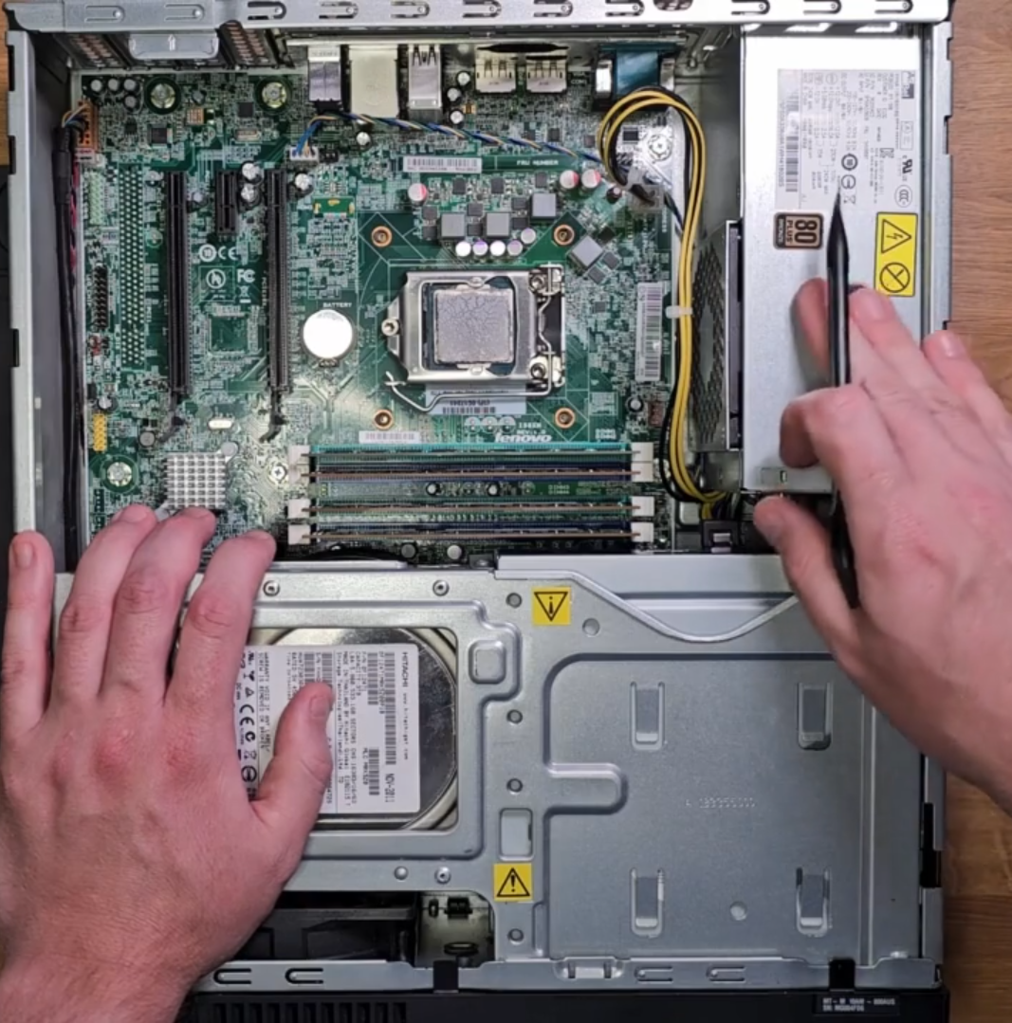

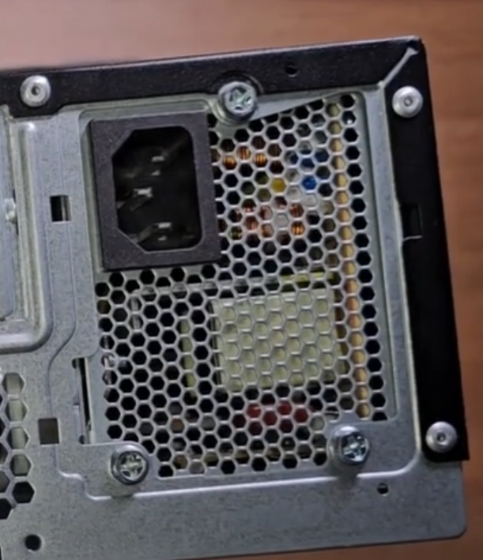

IEC Receptacle – generally called PC power plug

Always unplug the power supply before installing or removing it

### Graphical Processing Unit (GPU)

* **Function:** Handles visual processing and display.
* **Integrated GPU:** Built into the CPU. Less powerful, but sufficient for basic tasks.
* **Dedicated/External GPU:** A separate card plugged into the motherboard. More powerful for gaming, video editing, etc.
* **Connection:** Installs into a **PCI Express (PCIe)** slot on the motherboard.
* **Other PCIe Uses:** Slots can also hold other cards like Network Interface Cards (NICs) or sound cards.

### Motherboard (MOBO)

* **Function:** The main circuit board that connects all components (CPU, RAM, drives, etc.) and allows them to communicate.
* **Key Components:**
  + **CMOS Battery:** Powers the motherboard's memory (BIOS/UEFI settings) when the computer is off.
  + **CLR_CMOS Jumper:** Used to reset BIOS/UEFI settings to default (e.g., if a password is forgotten).
* **Selection Checklist:**
  + **CPU Socket:** Must match the processor.
  + **Chipset:** Determines features and compatibility.
  + **Form Factor:** Size (e.g., ATX, ITX) must fit the computer case.
  + **Ports:** Ensure it has enough USB, SATA, etc., ports for your needs.
  + **I/O Shield:** The rear plate with cutouts for ports.

### Ports, Cables and Peripherals

* **Power:** Main power connector from the PSU to the motherboard.
* **Video Ports:**
  + **VGA (Blue, D-Sub):** Analog, older standard.
  + **DVI (White):** Carries digital and analog signals.
  + **HDMI:** Digital video and audio.
  + **DisplayPort (DP):** Digital video and audio, newer standard.
  + **Adapters:** Convert between video standards (e.g., HDMI to VGA).
* **Data Ports:**
  + **USB-A:** Standard rectangular port.
  + **USB-B:** Often used for printers and scanners.
  + **USB-C:** Reversible, modern port for data, video, and power.
  + **Mini/Micro USB:** Older standard for smaller devices (phones, controllers).
  + **PS/2:** Legacy port for keyboards and mice (purple for keyboard, green for mouse).
  + **RJ45 (Ethernet):** For wired network connection.
* **Audio:**
  + **3.5mm Jack:** For audio (Line In - Blue, Line Out - Green, Microphone - Pink).

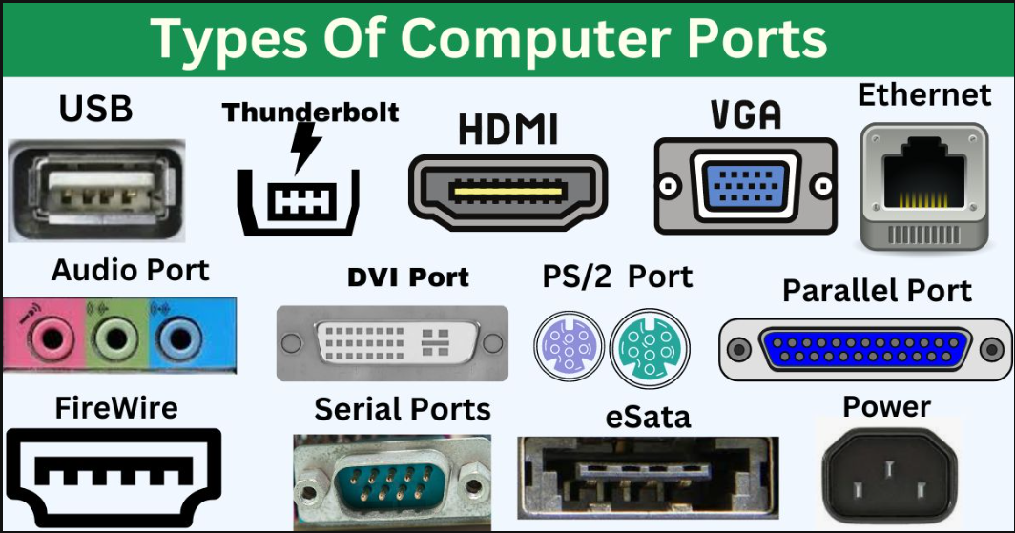

### POSTing and the BIOS

Power on self test (POST)

Beep codes

BIOS ( Basic Input and Output System ) – basic software/ firmware controls the hardware on the computer ( it is different than OS ) , it does not depend upon OS

Startup device menu

By defaults boots in the windows boot manager

Sometimes other options like network boots

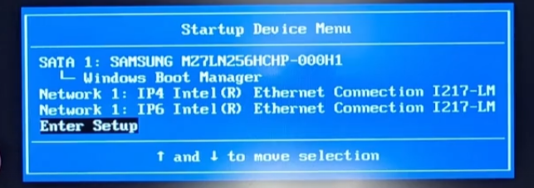

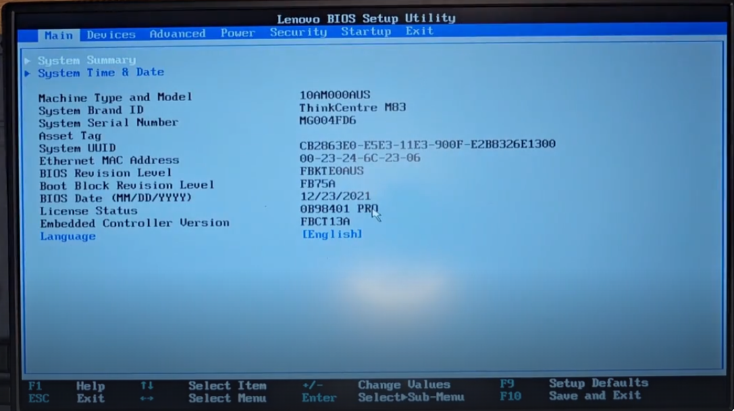

When opening BIOS why do fans sometimes run at max speed ?- The main purpose of the fans is to prevent critical components, especially the CPU, from overheating and causing permanent damage. The BIOS environment is a "known unknown" – the system doesn't know what tasks it might be performing for an extended period (like a memory test or a user browsing settings). Running the fans at full speed is the most reliable way to ensure adequate cooling under any circumstance. It's a conservative, safety-first approach.

Why do we need to enable virtualization in BIOS to work with VMs ?- **You enable virtualization in the BIOS to unlock your CPU's built-in ability to run virtual machines efficiently and securely. It transforms the process from a slow, software-based emulation into a fast, native hardware operation.**

System summary – a great place to check if any hardware changes made to the system are reflected properly

### Ticket Interrupt

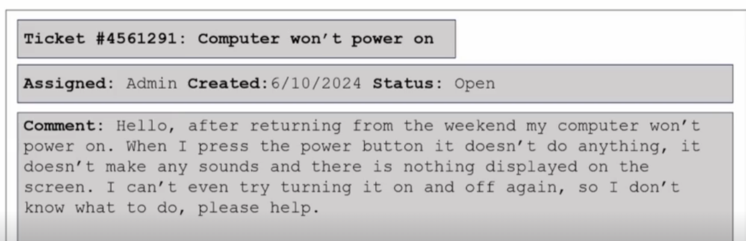

My process:

first verify do we have any damage to power source , connecting wires to actually verify if the system is receiving power ( do it on power off )

check any loose wires , any loose components in the CPU

Any kind of burning smell , to verify

BIOS if possible to get access , I don’t know further steps

Maybe based on these results we can proceed further

( well the actual answer is more technical like checking the CMOS battery , and each component working , deplug and replug - in practice mine is also in the right direction )

## 5.Laptop Computer Components and Repair

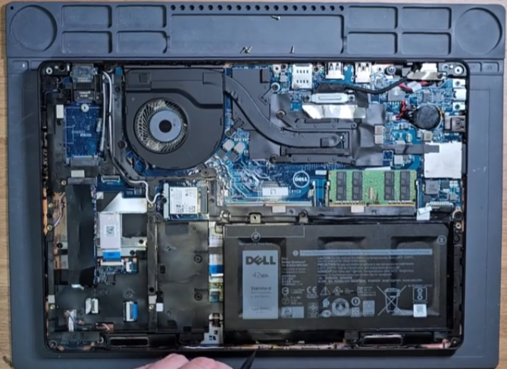

Battery

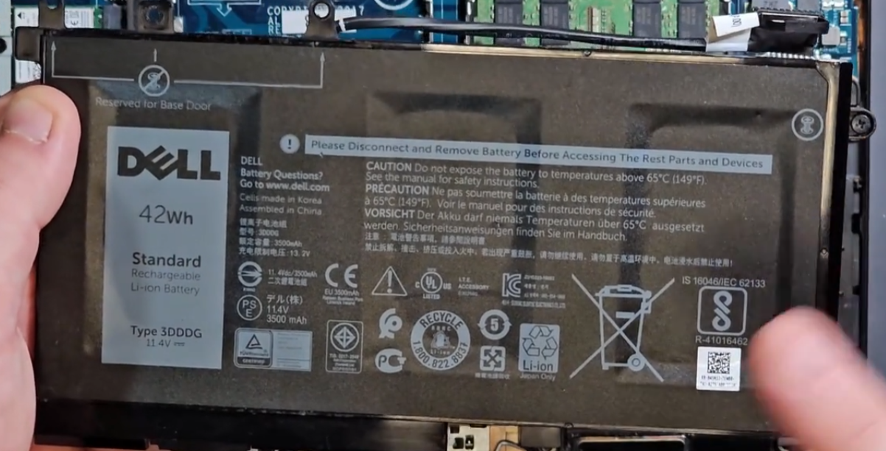

RAM

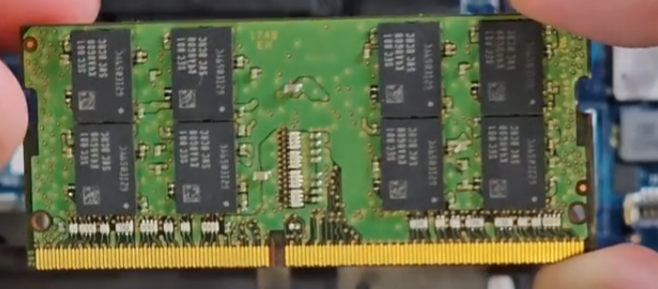

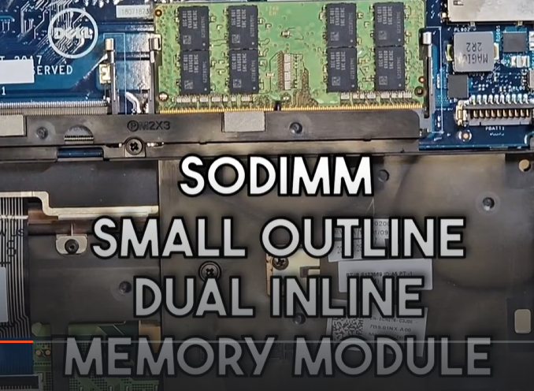

Laptop Drives

M.2 (SSD)

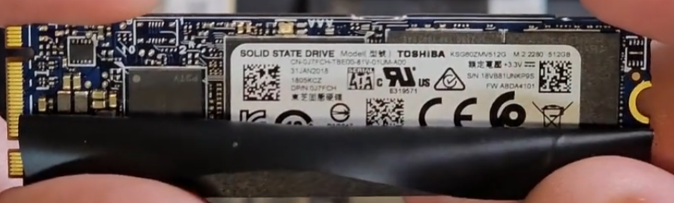

NVME

HDD (above SSD )

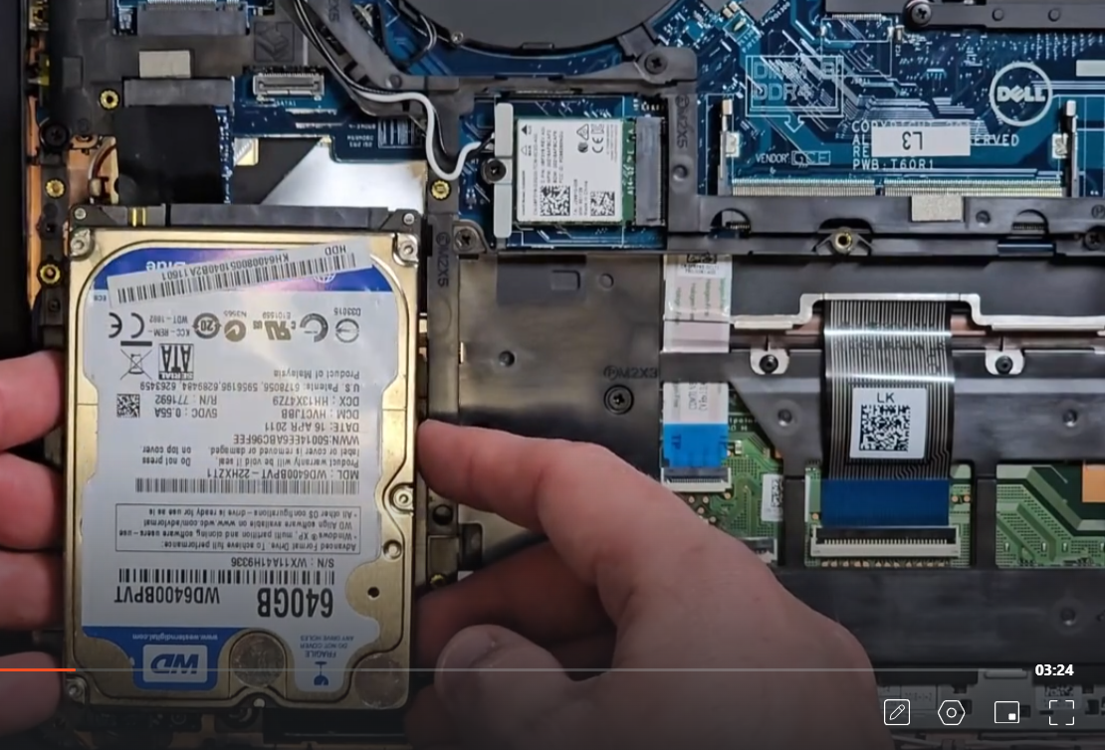

CMOS Battery

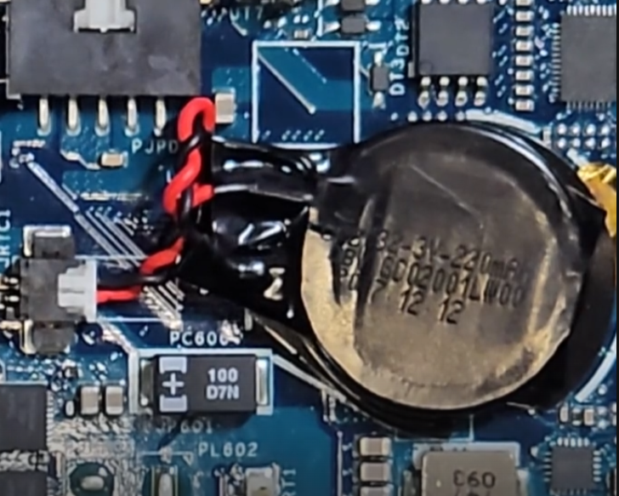

## 6.Operating Systems

The Operating System (OS) is software that manages computer hardware and provides common services for computer programs. It acts as an intermediary between the user/applications and the hardware.

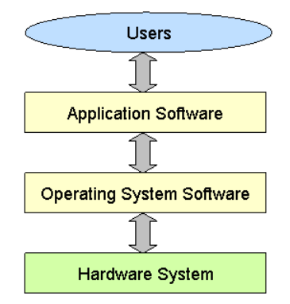

**Layered Architecture**

* **Userland:** The space where user applications and utilities run (e.g., Web Browser, Games, Office 365).
* **API (System Call Interface):** The defined set of functions that applications use to request services from the OS.
* **Kernel:** The core of the OS. It has direct access to the hardware and fulfills the requests made via the API.

The kernel manages all critical hardware components through drivers and subsystems

The primary role of the OS is **arbitration** – acting as a referee to manage conflicting demands for finite hardware resources. It ensures **Fair Access , Security & Protection , Efficiency.**

### File Systems

**1. Core Purpose**  
A File System is a method and data structure an operating system uses to control how data is stored and retrieved on a storage device (like a hard disk or SSD). It manages files and directories, and keeps track of where data is physically located.

**2. Evolution: From Manual to Automatic**

* **Old Method (Problem):** Users/programs had to manually track physical details of each file: its **starting address** on the disk, its **size**, and its **end address**. This was complex, error-prone, and inefficient.
* **Modern Solution (File Systems):** The file system automates this entirely. The user only sees logical file names and folders, while the file system handles all the physical storage details transparently.

**3. Types & Structure**

* **Different Formats:** Various operating systems use different, optimized file systems (e.g., **NTFS** for Windows, **APFS** for macOS, **EXT4** for Linux).
* **Hierarchical Structure:** Data is organized in a tree-like structure of directories (folders) and files.
  + In Windows, the top of each tree is a **drive letter** (e.g., C:\), representing a physical or logical disk volume.

**4. Key Concept: Arbitration**  
The file system acts as a manager, providing crucial arbitration functions:

* **Access Control:** Manages file **properties and permissions** (e.g., read, write, execute) to control which users or applications can access specific files.
* **Resource Management:** Enforces **storage quotas**, limiting how much disk space a user or application can consume to prevent one process from using all available space.
* **Concurrency Control:** Allows multiple programs to access the storage device simultaneously without corrupting data.

### File Types

**1. Core Purpose**  
File types inform the Operating System (OS) and applications how to interpret the data within a file. They determine which program should be used to open or execute the file.

**2. Primary Identification Method: File Extensions**

* **What it is:** A suffix at the end of a filename, following a period (e.g., .txt, .exe, .jpg).
* **How it works:** The OS maintains a registry linking each extension to a default application.
  + .exe → The OS understands this is an executable program.
  + .txt → The OS opens this in a text editor.

**3. Limitations of Extensions**

* A file can be created **without an extension**, but the OS will not know how to open it automatically, requiring the user to manually select a program.
* Extensions can be **changed or faked**, which can be a security risk (e.g., a malicious program disguised as a report.pdf.exe).

**4. Secondary Identification Method: Magic Bytes**

* **What it is:** Specific, standardized sequences of data found at the very beginning (the header) of a file.
* **Why it's important:** It provides a more reliable way to identify a file's true format, regardless of its name or extension.
  + **Example:** A JPEG image always begins with bytes FF D8 FF, and a PDF file begins with %PDF-.
* **Use Case:** Security software and applications use magic bytes to verify a file's actual type to prevent malware execution.

## 7.Virtualization

**Host Machine** → Physical system that runs virtualization.

**Hypervisor** → Manages VMs.

* **Type 1 (Bare Metal):** Runs directly on hardware (e.g., VMware ESXi, Microsoft Hyper-V, Proxmox).
* **Type 2 (Hosted):** Runs on top of an OS (e.g., VirtualBox, VMware Workstation).

**Resources Allocated:** CPU, RAM, Disk, Network.

**Advantages of Virtual Machines**

* **Safe Testing:** Isolated environment for malware analysis.
* **Faster Setup:** Quicker to install than a physical machine.
* **Isolation:** Can be disconnected from network.
* **Flexible Resources:** Adjust CPU/RAM/Disk as needed.
* **Snapshots:** Revert to previous state easily.
* **Agility:** Easy and fast deployment.
* **Cost Savings:** No need for full hardware per system.
* **Disaster Recovery:** Easier backups & recovery, especially on cloud

### Containers

* Run on **Host OS** without needing a full **Guest OS** per app.
* Lighter than VMs → virtualize **single applications**.
* Useful for **cloud** & **microservices** (scalable, efficient).
* Avoid overhead of multiple VMs for services like webservers.
* **Examples:** Docker, Kubernetes, Podman, LXC.

## 8.Windows

Configuration of Windows 11

### Windows Basics

* **Desktop:** Main screen with default apps and shortcuts.
* **Taskbar:** Start menu, search bar, multiple desktops, pinned apps.
* **App Window:** Minimize, resize, close.
* **File Explorer:** Access all files, navigation pane, pin folders/apps.
* **Drives:** Main drive = C:\ (stores system & user files), create folders/files.
* **File Operations:** Cut, copy, paste.
* **Shortcut:** Win + D → Show desktop.
* **System Tray (bottom right):** Network, sound, battery.
* **Settings App:** Change system preferences.

### Local and Domain Accounts

* **Local Account**
  + Created & stored **only on that computer**.
  + Username/password valid for **one system**.
  + Good for standalone PCs, not for large organizations.
  + Example: Manas (local user) → works only on that device.
* **Domain Account**
  + Stored & managed by a **Domain Controller (DC)** on a network/cloud.
  + Username/password valid across **all connected workstations/servers**.
  + Centralized management: policies, permissions, security settings applied by IT admins.
  + Example: manas@sampleco.org → login from any domain-joined computer.

👉 Local = tied to **one PC**. Domain = tied to **organization-wide system** (network/cloud).

Microsoft = cloud-based personal/SSO.

**Microsoft Account**

* A **single sign-on (SSO)** account tied to a Microsoft email (@outlook.com, @hotmail.com, etc.).
* Lets you log in to **multiple Windows devices** and Microsoft services (OneDrive, Office 365, Xbox, Teams).
* Syncs settings, files, and preferences across devices.

### Administering Local User Accounts

* **Access Tools**
  + Control Panel → *User Accounts*
  + Settings → *Accounts*
  + Run (Win + R) → lusrmgr.msc (Local Users and Groups Manager)
* **Tasks Possible**
  + Create new users (via *Users* folder).
  + Modify group membership of a user.
  + Delete/disable accounts.
  + Reset passwords.
* **Account Types**
  + **Standard User:** Limited rights, can use apps but cannot change system-wide settings.
  + **Administrator:** Full system access, can install apps, change security settings, manage users.
* **Example**
  + User Manas → Member of **Administrators** group → Has admin privileges.

👉 Quick rule: *Group membership defines the level of access.*

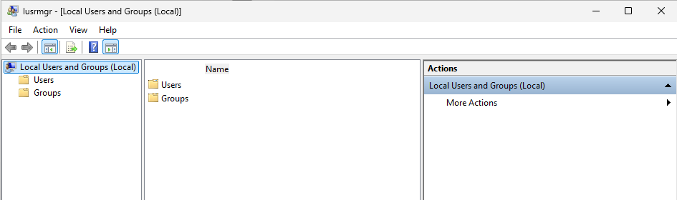

### Ticket Interrupt

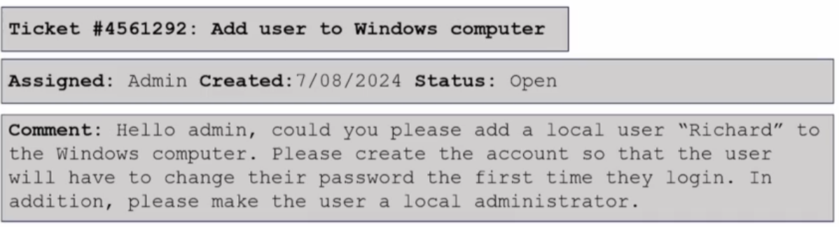

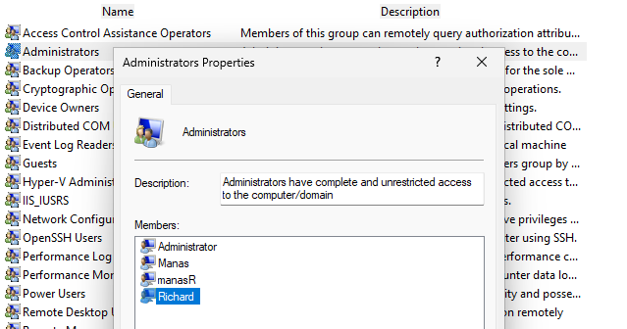

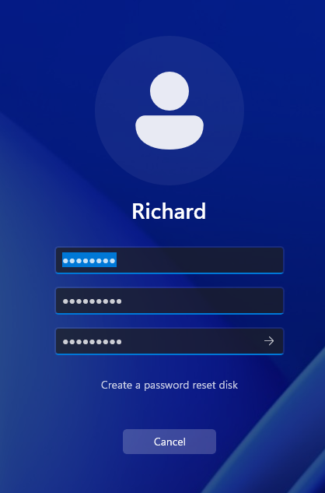 new password – password1

### Installing and Uninstalling Software

* **Install:** Usually via setup file (.exe/.msi) or Microsoft Store.
* **Uninstall:**
  + **Settings → Apps → Installed Apps** → Select app → *Uninstall*.
  + **Control Panel → Programs → Programs & Features** → Select program → *Uninstall*.

👉 Both methods remove software; Settings is modern, Control Panel is classic.

### Local File Permissions

**Check Permissions:** Right-click file/folder → *Properties* → *Security* tab.

**Authenticated Users** → all users who log in with a password.

**Deny > Allow** → if *Deny* is set, it overrides *Allow* (even for yourself).

**Administrators** → can still restore permissions despite Deny.

**Inheritance** → permissions often come from parent folder.

* To edit: *Advanced → Disable Inheritance → Apply*.

**Adding Permissions Back**:

* Add your user account → *Check Names* → set to *Allow*.

### Windows Update

* **Patch Tuesday** → 2nd Tuesday each month (security & fixes).
* **Out-of-Band Updates** → urgent/critical releases outside schedule.
* **Manual Check** → *Settings → Windows Update*.
* **Cumulative Updates** → include fixes & features; *preview versions* for testing compatibility.
* **KB Number** → each update has a Knowledge Base ID (can look up details online).
* **Pause Updates** → up to 5 weeks.
* **Update History** → view installed updates, uninstall if needed.
* **Recovery Options** → rollback updates if issues occur.
* **Active Hours** → set time when updates/restarts should not interrupt.

👉 Quick tip: Always check the **KB article** before installing, especially in enterprise environments.

### Windows Logs & Event Viewer

* **Event Viewer** → tool for viewing Windows logs, app/server logs, and remote logs (if configured).
* **Start Screen** → shows **summary of events**.
* **Viewing Events** → double-click an event to see details.
* **Windows Logs (Left Menu):**
  + **Application**
  + **Security**
  + **Setup**
  + **System**
  + **Forwarded Events**
* **Filter Current Log** → by time, event level, source, ID, keyword, user, or computer.
* **Details Tab** → shows in-depth info for a selected log.
* **Subscriptions** → collect logs from remote computers.

👉 Event Viewer = centralized place for **monitoring, troubleshooting, and auditing system activity**.

### Windows Device Manager

* **Purpose:** Manage hardware devices (USB, motherboard, ports, peripherals).
* **Drivers:** Software for OS ↔ hardware communication.
  + Most common drivers are pre-installed in OS.
  + Missing driver → ⚠️ Yellow exclamation (e.g., *Code 28: no compatible drivers*).
* **Update Driver:**
  + *Search automatically* (online).
  + *Browse my computer* (manual from trusted source).
* **Add Printer (Network):**
  + *Control Panel → Devices & Printers → Add a Printer* → select printer → done.

👉 Device Manager = **troubleshoot, update, and manage hardware drivers**.

### Windows Task Manager

* **Tabs/Sections:**
  + **Processes:** Apps, background, and Windows processes with resource usage.
  + **Performance:** Live graphs for CPU, Memory, Disk, Network, GPU.
  + **App History:** Resource usage over time.
  + **Startup:** Manage apps that run on startup.
  + **Users:** See logged-in users & their resource usage.
  + **Services:** View & manage Windows services.
* **Actions:**
  + **End Task** → kill unresponsive apps/processes.

👉 Task Manager = monitor **system performance** + manage **processes, apps, and services**.

### Windows Services

* **Definition:** Background programs in Windows that can be triggered manually, automatically, or by events.
* **Access:** services.msc (Run) or search **Services** in Start Menu.
* **Key Info for Each Service:**
  + **Status:** Running, stopped, paused.
  + **Startup Type:** Automatic, Manual, Disabled.
* **Actions:**
  + Start, Stop, Pause, Resume, Restart.
  + Change **Startup Type** to control how/when the service runs.

### Windows Registry

**Definition:** A database in Windows storing configuration settings for the OS and installed applications.

**Access:** regedit (Run) → opens **Registry Editor**.

**Purpose/Examples:**

* Stores desktop wallpaper location.
* Defines default apps for file extensions.
* Holds system and application settings.

**Structure:**

* **Keys:** Main containers, can have subkeys.
* **Values:** Store the actual data/settings.

**Root Keys:**

* **HKEY_CLASSES_ROOT (HKCR):** File associations, COM objects.
* **HKEY_CURRENT_USER (HKCU):** Settings for the logged-in user.
* **HKEY_LOCAL_MACHINE (HKLM):** System-wide settings.
* **HKEY_USERS (HKU):** All user profiles on the system.
* **HKEY_CURRENT_CONFIG (HKCC):** Current hardware profile settings.

**Notes:**

* Changes may require **restart or log off/on** to take effect.
* Useful for applying **hotfixes or tweaks** when UI options are unavailable.

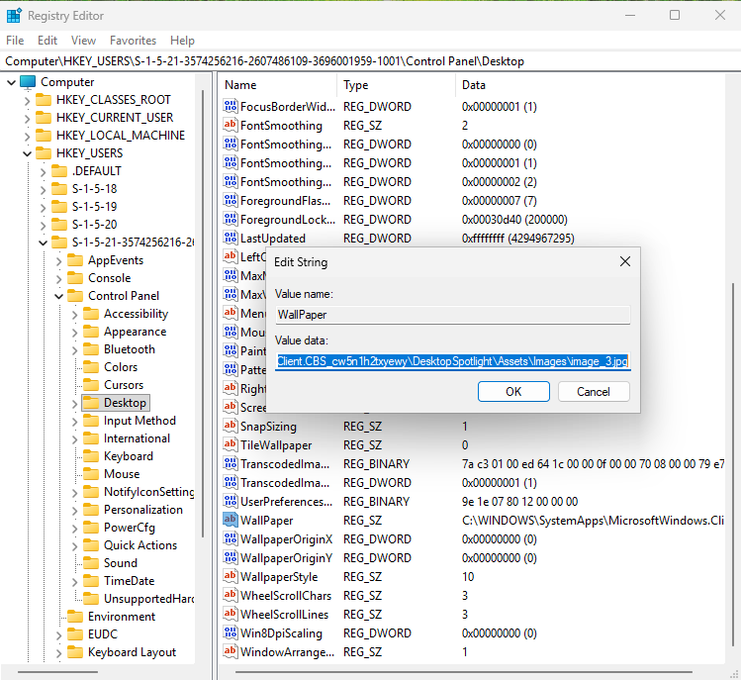

### Windows Command Prompt (CMD) Basics

* **Current Directory:** Displays the folder you are in before typing a command.
* **Common Commands:**
  + dir → Lists files/folders in the current directory.
  + cls → Clears the screen.
  + cd <folder> → Change directory.
    - cd Desktop → Navigate to Desktop. *(Tab for autocomplete)*
    - cd .. → Move up one directory.
    - cd C:\Users\Manas → Go to full path.
  + cd <filename> → Navigate to a file (if executable, can run it).
* **Networking Commands:**
  + ipconfig → Show network configuration.
  + ipconfig /? → Display help for ipconfig options.
  + ping <IP or hostname> → Test connectivity.
    - Example: ping 8.8.8.8
    - Ctrl + C → Stop the ping process.

### Windows Task Scheduler

* **Purpose:** Automates tasks in Windows, such as running programs, scripts, or system maintenance at scheduled times or triggers.
* **Access:** Task Scheduler (search in Start menu).
* **Creating a Task:**
  1. Open Task Scheduler → Click **Create Task**.
  2. **General Tab:** Name the task, set security options (run as admin if required).
  3. **Triggers Tab:** Define when the task runs (e.g., daily, at startup, on event).
  4. **Actions Tab:** Define what the task does (e.g., run a program, script, or send an email).
  5. **Conditions Tab:** Optional conditions (e.g., only run if idle, or on AC power).
  6. **Settings Tab:** Additional settings (e.g., allow task to run on demand, stop if runs too long).
* **Example Use Case:** Automate Disk Cleanup to run regularly without user intervention.
  1. Microsoft KB Article: [Automating Disk Cleanup](https://learn.microsoft.com/en-us/troubleshoot/windows-server/backup-and-storage/automating-disk-cleanup-tool)
* **Notes:** Tasks can be monitored, edited, or disabled from the Task Scheduler library.

## 9.Linux

**Hardware** ← **Kernel** ← **Operating System (OS)** ← **Applications/Software**

**Kernel:** Core of the OS that interacts directly with hardware. “Linux” technically refers to this.

**Linux Distribution (Distro):** The full OS most people use, e.g., Ubuntu, Fedora, Debian.

* Includes: **Linux kernel + GNU tools/utilities + package manager + desktop environment + applications**

**Open Source:** Linux is licensed under **GNU GPL** – anyone can read, audit, modify, contribute, and use it freely.

**Variations:** Many Linux kernel versions exist, forming different distros.

<https://en.wikipedia.org/wiki/List_of_Linux_distributions>

**Usage:** Dominant in the **server world** due to stability, flexibility, and open-source nature.

### Intro to Linux Terminal

**Prompt & context**

* manas@manas-ubuntu:~$ — manas = user, manas-ubuntu = hostname, ~ = current dir (home), $ = normal user prompt (root would show #).
* ~ expands to your home directory (/home/manas).

**Paths & navigation**

* pwd → print working directory (shows full path).
* ls → list files/dirs.
* cd Desktop → change directory (case-sensitive).
* cd .. → go up one level.
* cd ~ or just cd → go to home.
* cd / → go to root.
* Tab = autocomplete filenames & dirs.

**File & directory operations**

* mkdir Test → create directory Test.
* touch test.txt → create empty file or update timestamp.
* rm file → remove file; rm -r dir → remove dir recursively (be careful).
* cp src dest → copy.
* mv src dest → move/rename.

**Viewing & editing files**

* cat test.txt → dump file contents to terminal.
* cat -n test.txt or cat --number test.txt → show line numbers.
* gnome-text-editor test.txt → open GUI text editor (GNOME).
* nano, vim, less are common terminal editors/viewers (if installed).

**Help & manual pages**

* command --help → short usage/help for many commands (e.g., cat --help).
* man cat → full manual page for cat.
* man --help → options for man.

**Useful notes**

* Linux filenames and commands are **case-sensitive**.
* $ = regular user; # = root. Use sudo to run commands as root when needed (e.g., sudo apt update).
* ~ is shorthand for the current user’s home; . = current dir; .. = parent dir.

### Linux User Levels and Sudo

**Key files & IDs**

* /etc/passwd → user accounts (username, UID, home, shell).
  + cat /etc/passwd (contains root and user entries).
* /etc/shadow → password hashes (root-only readable).
  + cat /etc/shadow → **Permission denied** if not root.

**Useful commands**

* whoami → shows current user.
* id → shows UID, GID, groups.
* ls -l /etc/shadow → shows permissions (usually -rw-r----- root:shadow).

**sudo vs su**

* sudo <cmd> → run single command as root (asks *your* password).
  + sudo -l → list commands you’re allowed to run via sudo.
  + Example: sudo cat /etc/shadow (works only if your sudo policy allows it).
* su <user> → switch to another user (asks target user’s password).
  + su root → become root (requires root password).
* sudo su or sudo -i / sudo -s → become an interactive root shell using your sudo rights.

**Prompts**

* $ → normal user prompt.
* # → root prompt.

**Notes / Best practice**

* /etc/shadow is sensitive — only root should read it.
* Prefer sudo <cmd> for single commands; avoid staying root longer than needed.
* sudo -l helps discover permitted actions without escalating.
* Use exit or su <your-user> to return to your normal user.

### Linux Filesystem Hierarchy

**Starting point:**

* / → root directory (everything begins here)

**Core Directories**

* /bin → Essential binaries (programs like ls, cp, cat that all users need).
* /sbin → System binaries (administrative tools, usually for root).
* /lib → Shared libraries & kernel modules (needed by /bin and /sbin).

**User & Software**

* /usr → User applications & utilities.
  + /usr/bin → Most user commands.
  + /usr/sbin → Non-essential system binaries.
  + /usr/lib → Libraries for /usr/bin.
* /opt → Optional/add-on software (e.g., vendor apps).

**Configuration & System**

* /etc → System-wide configuration files (editable text configs).
* /dev → Device files (disks, USBs, terminals, etc. e.g., /dev/sda).
* /proc → Virtual filesystem exposing process & kernel info (e.g., cpuinfo, meminfo).
* /sys → Another virtual FS for kernel/hardware info (newer than /proc).

**Users & Data**

* /home → Personal directories for users (e.g., /home/manas).
* /root → Home directory of root user.
* /var → Variable data (logs, mail, spool, caches).
* /tmp → Temporary files (auto-cleaned, world-writable).

**Boot & Startup**

* /boot → Bootloader files (kernel, initrd, grub configs).
* /mnt → Mount point for temporary mounting of filesystems.
* /media → Mount point for removable media (USBs, CDs).

### Linux File Permissions

* **View permissions:**

ls -l

Shows file permissions, owner, group, size, and name.

* **Change file permissions:**

chmod 660 test.txt

* + 6 → read & write
  + First digit = owner, second = group, third = others
  + 660 → owner and group can read/write, others have no access
* **Change file owner:**

sudo chown root test.txt

Changes file owner to root.

* **Change file group:**

sudo chgrp root test.txt

Changes file group to root.

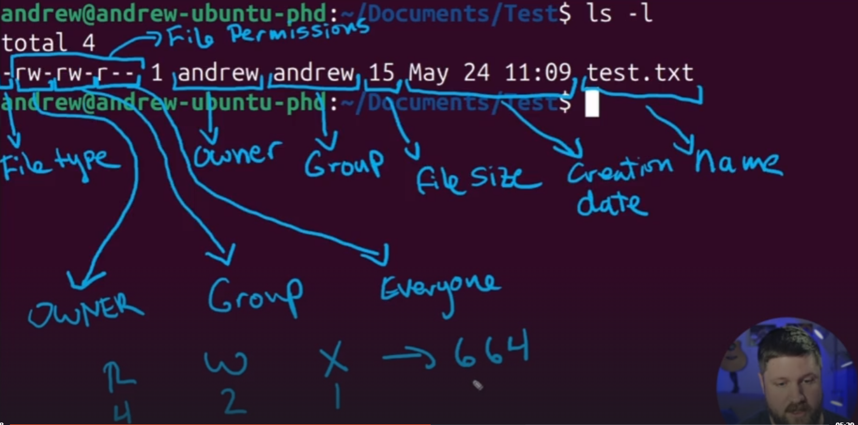

### Ticket Interrupt (Administering Users in Linux)

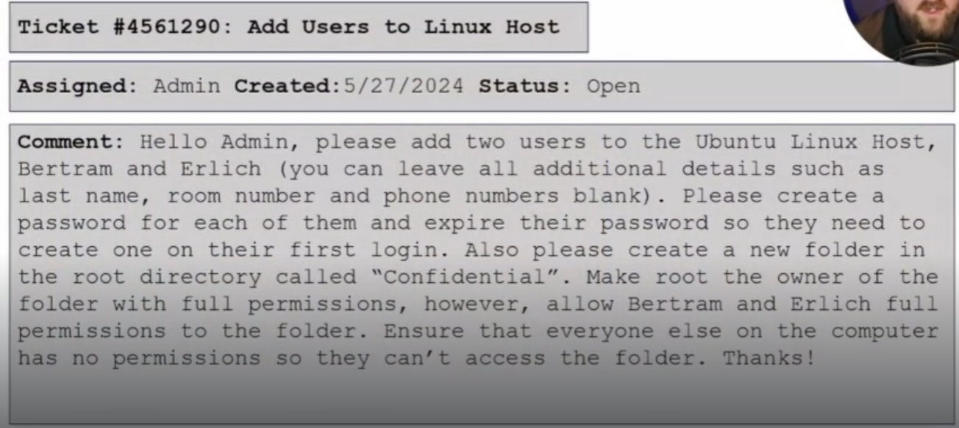

**Create a User in Linux**

1. **Add a new user:**

sudo adduser username

* Prompts to set a password and optional user info.
* Creates home directory /home/username by default.

1. **Set or change password (if needed):**

sudo passwd username

1. **Add user to a group (optional):**

sudo usermod -aG groupname username

* -aG → append user to the specified group without removing existing groups.

1. **Delete a user (optional):**

sudo deluser username

* Add --remove-home to delete home directory too.

sudo passwd --expire bertram

sudo passwd --expire erlich

sudo addgroup confidential

sudo usermod -a -G confidential erlich

sudo usermod -a -G confidential Bertram

sudo chgrp confidential

ls -l

sudo chmod 770 Confidential

### Intro to Bash Scripting

1. **Create a script:**

gnome-text-editor backup.sh

1. **Shebang:**

#!/bin/bash

* Tells the system to use **Bash** to run the script.

1. **Example script – Backup /Confidential:**

#!/bin/bash

# Script to backup the contents of /Confidential

# Store current date

date=$(date +%F)

echo "Current date read as: $date"

# Check if backup directory exists

if [ ! -f "/Backups/$date" ]

then

echo "/Backups/$date doesn’t exist, creating directory"

mkdir "/Backups/$date"

else

echo "Warning: /Backups/$date already exists, backup will overwrite"

fi

✅ **Note:**

* No spaces around = in assignments (date=$(...), not date = $(...)).
* Always use " (straight quotes) in scripts, not “smart quotes”.

1. **Make script executable:**

chmod +x backup.sh

1. **Run the script:**

* **Relative path:**
* ./backup.sh
* **From anywhere (add to PATH):**
* export PATH=$PATH:/path/to/script

backup.sh

### Scheduling Tasks with Cronjobs

1. **Correct permissions required** – user must have rights to run cron jobs.
2. **View existing cron jobs:**

crontab -l

1. **Edit cron jobs:**

crontab -e

* Opens a temp file in editor (choose option 1 = nano/vi).
* Save & exit → cron automatically installs the job.

1. **Examples:**

* Run every minute:
* * * * * * echo "hello world"
* Run daily at **7:30 AM:**
* 30 7 * * * echo "hello world"

⚡ **Cron time format:**

* * * * * command

| | | | |

| | | | └── Day of week (0-6, Sun=0)

| | | └──── Month (1-12)

| | └─────── Day of month (1-31)

| └────────── Hour (0-23)

└───────────── Minute (0-59)

### Upgrading & Installing Packages

**Debian/Ubuntu (APT-based distros)**

* **Update package lists (metadata):**

sudo apt update

* **Upgrade installed packages:**

sudo apt upgrade

* **Install a package:**

sudo apt install packagename

* **Remove a package:**

sudo apt remove packagename

## 10.Networking

### Intro to Networking Part 1 and 2

**1. IP Address**

* Logical address to identify devices on a network.
* Works like a postal address for sending/receiving data.

**2. IPv4 vs IPv6**

* **IPv4**: 32-bit, ~4.3 billion addresses, written as 192.168.1.1.
* **IPv6**: 128-bit, enormous range, written as 2001:0db8:85a3::8a2e:0370:7334.
* Today: Both used together (dual stack).

**3. Public vs Private IP**

* **Public IP**: Unique, given by ISP, visible on internet.
* **Private IP**: Used inside LAN, not routable on internet.
* Private ranges:
  + 10.0.0.0 – 10.255.255.255
  + 172.16.0.0 – 172.31.255.255
  + 192.168.0.0 – 192.168.255.255
* NAT translates private ↔ public at router.

**4. IP Classes (Classful Addressing – old method)**

* **Class A**: 1–126 → Large networks.
* **Class B**: 128–191 → Medium networks.
* **Class C**: 192–223 → Small networks.
* **Class D**: 224–239 → Multicast.
* **Class E**: 240–255 → Experimental.  
  *(Today CIDR/subnetting is used instead of strict classes.)*

**5. Network Topologies**

* **Bus**: Single cable backbone.
* **Star**: Devices connect to central hub/switch.
* **Ring**: Devices in a closed loop.
* **Mesh**: Every node connected to every other.
* **Hybrid**: Combination (common in practice).

**6. How Internet Access Works**

LAN Device (Laptop) → Router → Modem/ISP → Internet Backbone → Destination Server (e.g., Google)

* Router gives private IP to device.
* ISP gives public IP to router.
* NAT + Routing move packets between private and public networks.

**7. DNS (Domain Name System)**

* Works like a phonebook for the internet.
* Converts domain names → IP addresses.
  + Example: www.google.com → 142.250.193.14

### OSI Model

**✅ Basics**

* **Full form**: *Open Systems Interconnection*.
* Made by **ISO (International Organization for Standardization)**.
* Purpose: **Conceptual guide** for networking, troubleshooting, and communication.
* Not an actual protocol → it’s a **reference model**.
* Has **7 layers** (mnemonic: **P-D-N-T-S-P-A**).

**✅ 7 Layers of OSI Model**

1. **Physical Layer**
   * Deals with hardware, signals, cables, bits.
   * Examples: Ethernet cables, hubs, voltages.
2. **Data Link Layer**
   * Responsible for node-to-node delivery.
   * Adds **MAC addresses**, error detection (CRC).
   * Devices: Switches, NIC.
   * Protocols: Ethernet, PPP.
3. **Network Layer**
   * Responsible for logical addressing & routing.
   * Adds **IP addresses**.
   * Devices: Routers.
   * Protocols: IP, ICMP.
4. **Transport Layer**
   * Ensures **reliable end-to-end delivery**.
   * **Segmentation, flow control, error recovery**.
   * Protocols: TCP (reliable), UDP (fast, no guarantee).
5. **Session Layer**
   * Manages sessions (opening, maintaining, closing).
   * Example: Logging into a remote server.
6. **Presentation Layer**
   * Translates data into a format the application understands.
   * Handles **encryption, compression, encoding**.
   * Example: SSL/TLS, JPEG, MP3.
7. **Application Layer**
   * Closest to the user → provides services.
   * Protocols: HTTP, FTP, SMTP, DNS.

### Network Addresses and Subnet Masks

**1. Subnet Mask**

* Splits an IP into **Network** and **Host** parts.
* Example: 192.168.1.25 /24 → Network = 192.168.1, Host = .25.

**2. Default Gateway**

* Router’s IP = **path to internet/outside networks**.
* Without it → only local devices talk.

**3. Broadcast Address**

* Sends data to **all devices** in a subnet.
* Rule: All host bits = 1.
* Example: 192.168.1.25/24 → Broadcast = 192.168.1.255.

**4. Subnetting**

* Breaking a big network into **smaller subnets**.
* Benefits: Saves IPs, reduces congestion, improves security.
* Example: 192.168.1.0/24 → split into /26 = 4 subnets of 64 addresses each.

**5. CIDR (Classless Inter-Domain Routing)**

* Format: IP/number.
* /number = **network bits** (rest = host bits).
* Example: 192.168.1.0/24 = Subnet Mask 255.255.255.0.
* Must be **contiguous bits** (e.g., /9 = 255.128.0.0).

**6. Quick Host Calculation**

Formula: 2^(host bits) – 2 = usable hosts.

* /24 → 8 host bits → 254 hosts.
* /25 → 7 host bits → 126 hosts.

### Hubs , Switches(layer 2) and ARP

**📒 Hubs, Switches & ARP**

**1. Hub**

* Simple network device.
* Broadcasts data to **all ports**.
* Works at **Layer 1 (Physical Layer)**.
* No intelligence, no filtering.

**2. Switch**

* Works at **Layer 2 (Data Link Layer)**.
* Sends data **only to the intended device** using MAC addresses.
* Types:
  + **Managed Switch** → Can configure VLANs, monitor traffic, control ports.
  + **Unmanaged Switch** → Plug-and-play, no configuration, basic connectivity.

**3. ARP (Address Resolution Protocol)**

* Converts **IP address → MAC address**.
* Devices use **ARP tables** to store known IP-to-MAC mappings.
* Example:
  + PC wants to send data to 192.168.1.10
  + Looks up MAC in ARP table → sends directly.
* Helps switches deliver frames correctly.

✅ **Quick Recall**

* **Hub** → dumb, broadcasts to all.
* **Switch** → smart, sends to target MAC.
* **Managed switch** → configurable, monitorable.
* **Unmanaged switch** → simple plug-and-play.
* **ARP** → maps IP → MAC for communication.

### Routers

**Router**

* Connects **different networks** (e.g., LAN → Internet).
* Forwards data between networks based on **IP addresses**.
* Can assign private IPs to devices in the LAN.

**2. Network Address Translation (NAT)**

* Translates **private IPs → public IP** for internet communication.
* How it works:
  1. Device sends request: 192.168.1.10 → Internet.
  2. Router replaces private IP with **its public IP**.
  3. Response from Internet → Router maps back to the correct private IP.
* Allows **many devices** to share a single public IP.

✅ **Quick Recall**

* **Router** → Connects networks, forwards traffic.
* **NAT** → Lets private IPs communicate on the Internet using a public IP.

### Setting up a SOHO(Small Office Home Office) router

**1. What is a SOHO Router?**

* Small Office/Home Office router for connecting **a few devices to the Internet**.
* Provides: **LAN connectivity, Wi-Fi, NAT, basic firewall**.

**2. Steps to Set Up a SOHO Router**

1. **Physical Setup**
   * Connect **WAN port** → ISP modem.
   * Connect **LAN ports** → PCs or switches.
   * Power on router.
2. **Access Router Admin**
   * Open a browser → enter default IP (e.g., 192.168.1.1).
   * Login with default credentials (check manual).
3. **Configure LAN & DHCP**
   * Set LAN IP range (e.g., 192.168.1.1/24).
   * Enable DHCP to **automatically assign private IPs** to devices.
4. **Configure Wi-Fi (if needed)**
   * Set **SSID** (network name) and **password**.
   * Choose encryption: **WPA2/WPA3**.
5. **Configure NAT / Internet Access**
   * WAN interface gets **public IP** from ISP.
   * NAT allows all internal devices → Internet via router’s public IP.
6. **Optional Security Settings**
   * Enable **firewall**.
   * Disable remote management unless required.
   * Change default admin password.

✅ **Quick Recall**

* SOHO router = small office/home internet & LAN hub.
* Steps: **Connect → Login → LAN/DHCP → Wi-Fi → NAT → Security**.

### Ports

**1. What is a Port?**

* Logical number for **specific applications/services** on a device.
* IP = house, Port = room number.

**2. Port Ranges**

* **0–1023** → Well-known ports (HTTP=80, HTTPS=443, SSH=22)
* **1024–49151** → Registered ports (applications)
* **49152–65535** → Dynamic/private ports (temporary client ports)

**3. TCP vs UDP**

* TCP → Reliable, connection-oriented (HTTP, SSH, FTP)
* UDP → Fast, connectionless (DNS, streaming)

**4. netstat -tulpna (Linux)**

* Command to **see active connections and listening ports**.
* Flags:
  + -t → TCP connections
  + -u → UDP connections
  + -l → Listening ports
  + -p → Show process using the port
  + -n → Show IPs/ports numerically
  + -a → Show all sockets

**Example Output:**

Proto Recv-Q Send-Q Local Address Foreign Address State PID/Program

tcp 0 0 0.0.0.0:22 0.0.0.0:* LISTEN 1234/sshd

udp 0 0 0.0.0.0:53 0.0.0.0:* 5678/named

* Shows **which ports are open/listening**, which protocol, and which process owns them.
* Useful for **troubleshooting & security auditing**.

✅ **Quick Recall**

* Ports = rooms in the IP house.
* TCP = reliable, UDP = fast.
* netstat -tulpna → list all listening TCP/UDP ports + processes.

### Ticket Interrupt

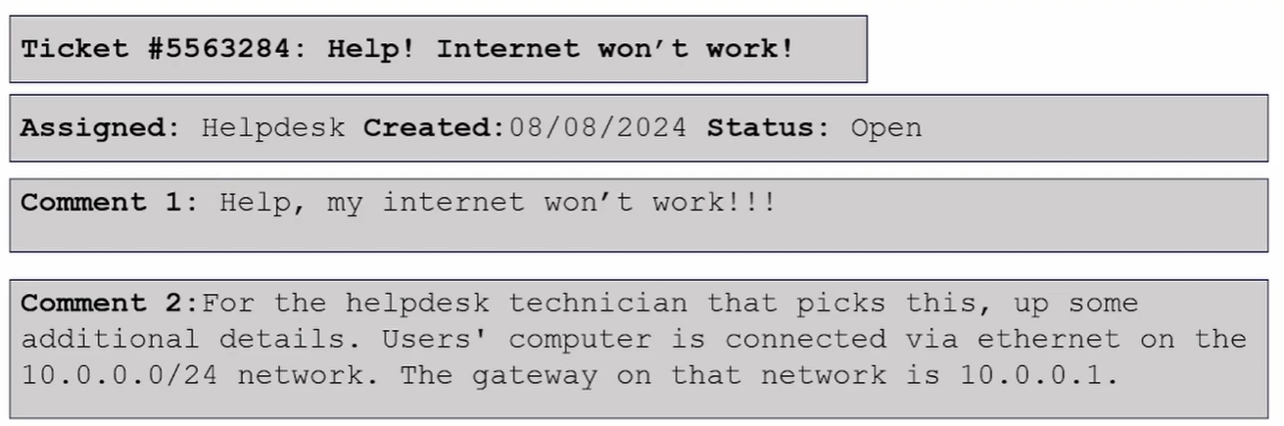

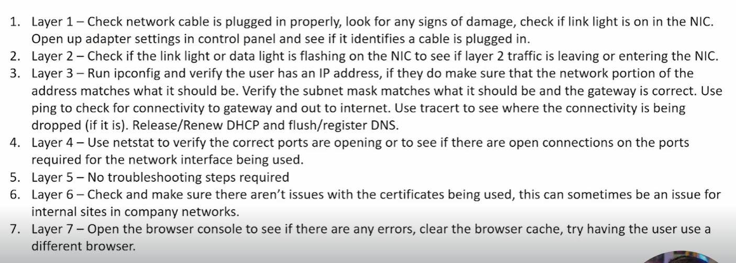

### VPNs (Virtual Private Networks )

A **Virtual Private Network (VPN)** creates a secure, encrypted connection (“tunnel”) between your device and the internet. It hides your IP address and routes traffic through a VPN server, ensuring privacy, security, and anonymity.

**🔑 Key Features of VPNs**

* **Encryption**: Data is encrypted (e.g., AES-256) → prevents eavesdropping.
* **Tunneling Protocols**: e.g., PPTP, L2TP/IPSec, OpenVPN, WireGuard.
* **IP Masking**: Hides your real IP → replaces with VPN server’s IP.
* **Remote Access**: Allows secure access to private networks from anywhere.

**📌 Uses of VPNs**

1. **Security** → Protects against hackers on public Wi-Fi.
2. **Privacy** → Hides browsing activity from ISPs, trackers.
3. **Bypass Geo-restrictions** → Access region-locked content.
4. **Remote Work** → Employees access corporate networks securely.
5. **Censorship Bypass** → Used in restrictive regions.

**⚙️ Types of VPN**

* **Remote Access VPN** – For individuals connecting to private networks.
* **Site-to-Site VPN** – Connects entire networks (e.g., branch offices).
* **Personal VPN Services** – Commercial providers (NordVPN, ProtonVPN, etc.).

**🛡️ Limitations**

* Slower speeds (due to encryption).
* VPN provider must be trusted (they may log traffic).
* Some services block known VPN IPs.

✅ **In short**:  
A **VPN = Security + Privacy + Remote Access** via encrypted tunneling and IP masking.

### Network Troubleshooting Commands

* **ping [IP/Domain]** → Tests connectivity (e.g., ping 192.168.50.1, ping google.com).  
  *Note: Some devices block ping replies for security.*
* **ipconfig** → Shows basic network configuration.
* **ipconfig /all** → Detailed configuration (DNS, MAC, DHCP, etc.).
* **ipconfig /release** → Releases current IP address.
* **ipconfig /renew** → Requests a new IP from DHCP.
* **ipconfig /displaydns** → Shows cached DNS entries.
* **ipconfig /flushdns** → Clears DNS cache.
* **ipconfig /registerdns** → Refreshes DNS registration.
* **tracert [domain]** → Traces route packets take to a host (e.g., tracert www.tcm-sec.com).
* **netstat** → Shows active connections, listening ports, and routing table.
* **arp -a** → Displays ARP table (IP ↔ MAC mapping).
* **arp --help** → Lists ARP command options.

## 11.Remote Support

### SSH

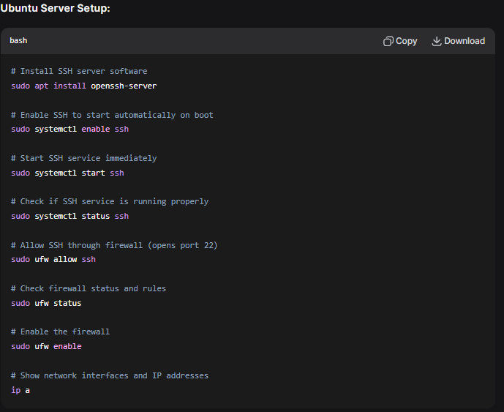

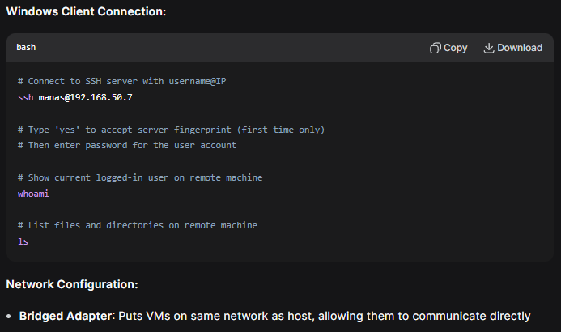

Setting up a key-pair instead of a password

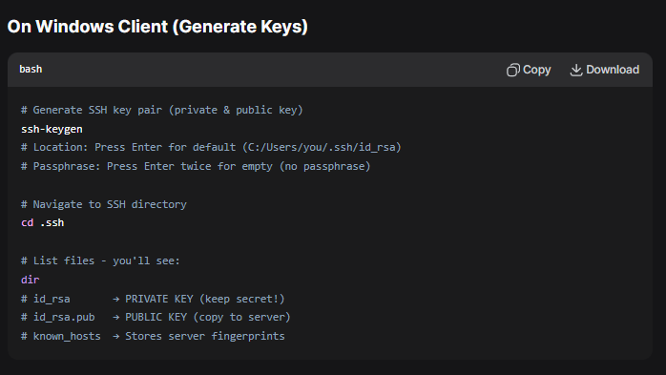

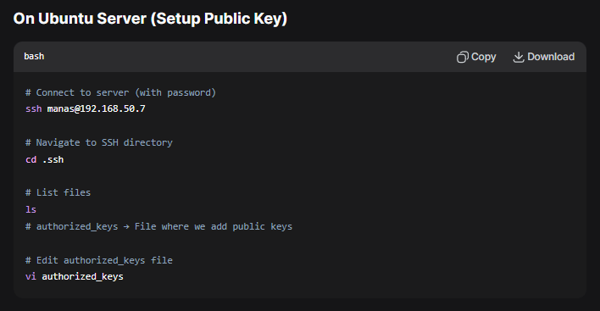

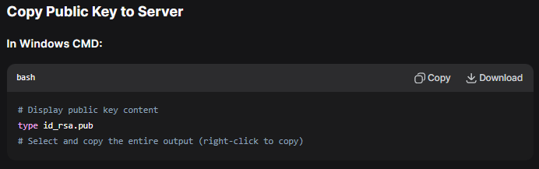

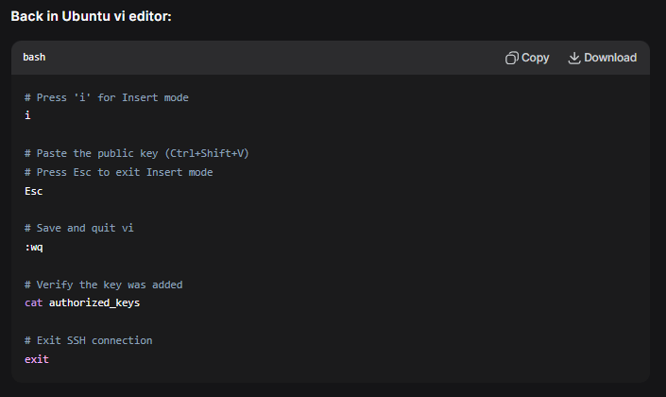

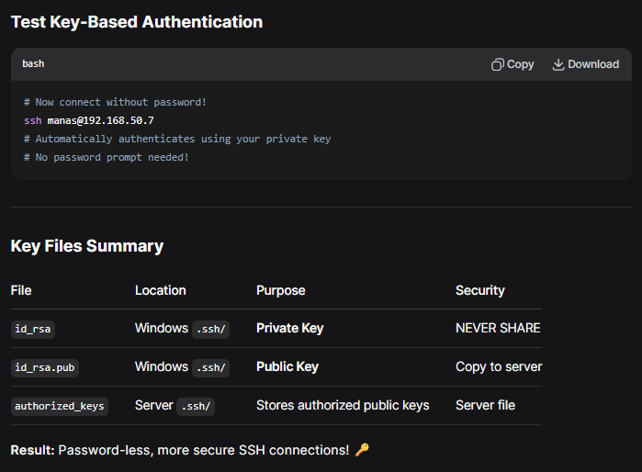

### Remote Desktop (RDP)

**Objective:** Control a Windows 11 computer remotely from another machine.

**1. Setup the Windows 11 "Server" (The PC you want to connect TO)**

* Go to **Settings** > **System** > **Remote Desktop**.
* **Enable** "Remote Desktop".

**2. Connect from a Client (The PC you are connecting FROM)**

**From Ubuntu (Linux) Client:**

* **Install the client:** sudo apt install remmina
* **Launch Remmina** and create a new connection.
* **Enter:**
  + **Protocol:** RDP
  + **Server:** IP address of the Windows 11 PC.
  + **Username & Password:** Your Windows login credentials.

**From Windows Client:**

* Press **Win + R**, type mstsc and press Enter.
* In the "Remote Desktop Connection" window, enter the **IP address** of the Windows 11 PC.
* Enter your **Username** and **Password** when prompted.

**⚠️ Important Note**

* Logging in via RDP **may log out** any user currently using the Windows 11 PC.

### VNC (Virtual Network Computing)

**Objective:** Remotely control a computer's GUI (Graphical User Interface). It's an older, cross-platform protocol.

**1. Setup the Windows "Server" (PC to connect TO)**

* Download and install **TightVNC**.
* During setup, **set a password** for remote access.
* **TightVNC Server** will run in the background.

**2. Connect from a Client (PC you are connecting FROM)**

**From Ubuntu (Linux) Client:**

* Open **Remmina**.
* Select **VNC** as the protocol.
* **Enter:**
  + **Server:** IP address of the Windows PC.
  + **Password:** The VNC password you set during TightVNC setup.

**🆚 RDP vs. VNC - Key Difference**

* **RDP** (on Windows) creates a *new, virtual session* or takes over the current one.
* **VNC** transmits the *actual live screen*, allowing you to see and interact with what's physically displayed on the monitor.

### 3rd Party Remote Support Applications

**What it is:** Cloud-based services that simplify remote connections, bypassing firewalls and complex network configuration. Ideal for quick support.

**How it Works:**

1. Both the supporter and the user run the TeamViewer software.
2. The user provides their **TeamViewer ID and Password** (which changes each session by default for security).
3. The supporter enters this ID to connect.

**Key Features & Details:**

* **No Network Configuration:** Works through firewalls without needing to open ports.
* **Web Client:** The supporter can just go to the TeamViewer website, enter the ID, and connect through a browser tab without installing any software.
* **Cross-Platform:** Connects Windows, Mac, Linux, and even mobile devices.
* **Additional Tools:** Includes file transfer, chat, and session recording.
* **Security:** Uses end-to-end encryption. The temporary password provides good security for one-off support sessions.

**Other Popular 3rd Party Apps:**

* **AnyDesk:** Similar to TeamViewer, known for its speed.
* **Splashtop:** Good balance of performance and cost for personal/business use.
* **Chrome Remote Desktop:** A simple, free solution if both users are in the Chrome browser.

### Tips and Tricks for Phone Support

**Before the Call:**

* If possible, establish a **remote connection** to see their screen directly. This is the fastest way to understand the issue.
* Have your own computer ready to follow along with any procedures.

**During the Call:**

1. **Troubleshoot Methodically:**
   * Listen carefully to identify the root problem.
   * Apply the fix once you understand the cause.
2. **Give Clear Instructions:**
   * Provide **clear and concise, step-by-step instructions**.
   * **Avoid using technical acronyms and jargon** (e.g., say "the address bar at the top of the internet browser" instead of "the URL field").
   * **Do not skip steps, even the obvious ones** (like "click OK" or "press the Enter key"). What seems obvious to you may not be to them.
3. **Guide Through Procedures:**
   * If you don't have a pre-written guide, **perform the steps on your own computer as you explain them**. This helps you give accurate and timely instructions.
   * Confirm each step has been completed before moving to the next.

## 12.Ticketing

**Purpose:** Essential for organizing, tracking, and resolving support requests efficiently.

**Key Benefits:**

* **Organization:** Centralizes all requests, preventing loss.
* **Accountability:** Clear ownership for each issue.
* **Priority Management:** Urgent issues get addressed first.
* **Knowledge Base:** Creates searchable resolution history.
* **Performance Metrics:** Tracks response times and success rates.

**Common Software:**

* **ServiceNow** (Enterprise)
* **Zendesk** (User-friendly)
* **Zoho Desk** (Cost-effective)

**Key Metadata:**

* Ticket ID, Status, Priority
* Requester, Assignee, Category
* Time logs, Internal notes, Attachments

### Peppermint (Open Source Ticketing) Setup on Ubuntu

**1. Install Docker on Ubuntu:**

bash

# Follow the official Docker installation guide:

https://docs.docker.com/engine/install/ubuntu/

* Uninstall old conflicting packages (not needed for new VMs)
* Set up Docker's apt repository (copy/paste commands from guide)
* Install Docker packages (copy/paste commands from guide)
* Verify: sudo docker run hello-world

**2. Setup Peppermint:**

bash

mkdir peppermint && cd peppermint

# Get docker-compose.yml from:

https://docs.peppermint.sh/docker

bash

vi docker-compose.yml

# Press 'I' for insert mode, paste (Ctrl+Shift+V)

# Change API_URL to: https://localhost:5003

# Save: Esc → :wq

# Verify: cat docker-compose.yml

**3. Run & Access:**

bash

sudo docker compose up

# Wait for installation to complete

# Access at: http://localhost:3000

# Login: admin@admin.com / 1234

**4. Container Management:**

* Start: sudo docker compose up
* Stop: sudo docker compose down

**5. Key Features to Explore:**

* Dashboard overview
* Add users & clients
* Set priorities & issue types
* Open/close tickets
* Escalate tickets
* Track ticket status

### Ticket Interrupt

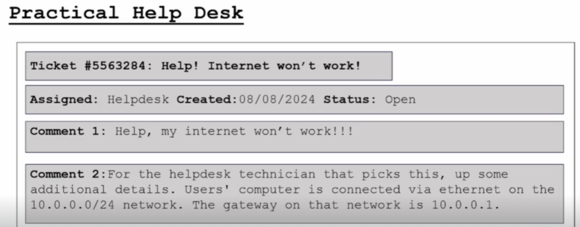

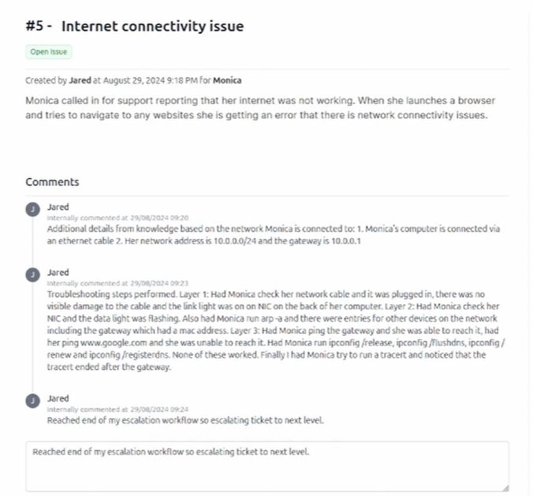

## 13.Security

### CIA Triad

The CIA Triad is the foundational model for information security, forming the basis for developing security systems and policies. It consists of three core principles:

**1. Confidentiality**

* **Core Idea:** Ensuring that data is **not accessed** by unauthorized individuals or systems.
* **It's about:** **Privacy and secrecy.**
* **Analogy:** A sealed letter in a locked mailbox. Only the intended recipient has the key.
* **Common Tools/Methods:**
  + Encryption
  + Access Control Lists (ACLs)
  + Passwords & Multi-Factor Authentication (MFA)
  + Data Classification

**2. Integrity**

* **Core Idea:** Protecting data from **unauthorized alteration or deletion**, ensuring it is **accurate and trustworthy**.
* **It's about:** **Trustworthiness and reliability.**
* **Analogy:** A tamper-evident seal on a medicine bottle. You can trust the contents haven't been changed.
* **Common Tools/Methods:**
  + Hashing (e.g., SHA-256)
  + Digital Signatures
  + Checksums
  + Version Control Systems

**3. Availability**

* **Core Idea:** Ensuring that data and systems are **accessible and operational** when needed by authorized users.
* **It's about:** **Reliable access.**
* **Analogy:** A 24/7 public utility like electricity. It's there when you need it.
* **Common Tools/Methods:**
  + Redundancy (e.g., backup servers, RAID)
  + Disaster Recovery Plans
  + Regular patching and maintenance
  + DDoS Mitigation Services

### Firewall, Antivirus (AV) , Endpoint Detection and Response(EDR) , Security Incident and Event Management (SIEM)

#### Firewall = Digital Security Guard

* **Position:** Network entrance/exit
* **Job:** Check all incoming/outgoing traffic
* **Tools:** Rulebook (security policies)
* **Action:** ✅ Allow or ❌ Block
* **Goal:** Keep bad traffic out, let good traffic through

**Smart Features:**

* Remembers ongoing conversations (stateful)
* Uses fast, dedicated hardware
* Processes millions of packets/second

#### Antivirus Software

**Purpose:** Detect, block & remove malware from a computer.

**How It Works:**

1. **Signature Checking:** Compares files against database of known malware "fingerprints"
2. **Behavior Monitoring:** Watches for suspicious actions (like unauthorized file encryption)

**Key Actions:**

* **Block** malicious files from running
* **Quarantine** infected files to prevent spread
* **Remove** malware from the system

**Limitation:** Must be regularly updated to recognize new threats

**Bottom Line:** Essential first-line defense that uses multiple techniques to catch both known and unknown threats.

#### EDR (Endpoint Detection and Response)

**Core Concept:** An advanced security system that **proactively hunts for threats** across all endpoints in a network.

**How It Works:**

1. **Data Collection:** A small **agent** is installed on every endpoint (computer) to collect **telemetry**.
2. **Telemetry Sources:** Continuously gathers deep data from multiple sources:
   * Process execution
   * Network connections
   * File system changes
   * User logins
   * Registry modifications
3. **Centralized Analysis:** Sends all data to a central platform for correlation.
4. **Threat Detection:** Uses **analytics and algorithms** to automatically detect suspicious patterns and advanced threats that antivirus would miss.

EDR->SIEM->SOAR (std work flow in most organizations )

#### SIEM (Security Information and Event Management)

**What:** Central security "brain" that collects and analyzes data from across your IT environment.

**Key Functions:**

* **Collects** logs from all systems (firewalls, servers, EDR, etc.)
* **Correlates** events to find hidden attack patterns
* **Alerts** on suspicious activities
* **Stores** data for investigations and compliance

**How It Works:**

1. Gathers security data from everywhere
2. Normalizes and analyzes it
3. Identifies threats by connecting dots
4. Alerts security team

**Value:** Provides centralized visibility - can see attacks that span multiple systems which individual tools would miss.

**Core Purpose:** **Detection through correlation** - finds sophisticated threats by analyzing relationships between seemingly unrelated events.

### IAM , MFA and SSO

#### IAM (Identity & Access Management)

* **What:** Framework for managing **digital identities** and their **access rights**.
* **The 4 A's:**
  1. **Administration:** Managing user accounts and permissions
  2. **Authentication:** Verifying user identity (login)
  3. **Authorization:** Determining what they can access
  4. **Auditing:** Tracking and logging access for compliance

#### SSO (Single Sign-On)

* **What:** Technology that lets users access **multiple applications** with **one login**.
* **Benefit:** User convenience + easier security management
* **Risk:** Single point of failure (but easier to secure one strong login)

#### MFA (Multi-Factor Authentication)

* **What:** Requires **2+ verification factors** to login
* **Factors:**
  + **Knowledge** (password/PIN)
  + **Possession** (phone app, security key)
  + **Inherence** (biometrics - fingerprint/face)
* **Purpose:** Adds critical security layer beyond passwords alone

**How They Work Together**

**IAM** is the **overall framework** that uses **SSO** for user convenience and **MFA** for strong security, creating a complete identity and access security system.

### Social Engineering

**Definition:** The psychological manipulation of people to trick them into revealing sensitive information or performing actions that compromise security.

**Purpose:** A common method for cybercriminals to gain **initial access** to a network or data.

**The 3 Common Manipulation Tactics (Red Flags):**

1. **Urgency:** Creates pressure to act quickly without thinking.
2. **Request for Sensitive Info:** Asks for passwords, PINs, or access codes.
3. **Personation/False Pretext:** Pretends to be someone else (IT support, executive, vendor) with a fabricated story.

**Key Tips to Avoid It:**

* **Verify Identity Independently:** Don't use contact details the caller provides. Hang up and call back on a known, official number.
* **Slow Down & Question Urgency:** Legitimate matters rarely require immediate, irreversible action.
* **Never Share Passwords or MFA Codes:** No legitimate organization will ever ask for these.
* **Be Skeptical of Unsolicited Contact:** Whether by phone, email, or text.
* **Think Before You Click:** Hover over links to see the real URL and be wary of unexpected attachments.

### Phishing & ishing Attacks

**Core Concept:** Social engineering attacks that use deception to steal data, money, or access.

**Common Goals:**

* Steal login credentials (email, bank)
* Install malware (ransomware, spyware)
* Harvest personal/financial information
* Gain initial foothold in an organization

**\**Types of ishing Attacks***

| Type | Method | Target |
| --- | --- | --- |
| **Phishing** | Mass emails with malicious links/attachments | Broad audience |
| **Spear Phishing** | Highly personalized, researched emails | Specific individuals |
| **Whaling** | Spear phishing targeting executives | CEOs, senior management |
| **Smishing** | Malicious text messages | Mobile users |
| **Vishing** | Fraudulent phone calls | Anyone with phone |
| **SEO Poisoning** | Poisoned search results | Search engine users |

**How to Identify Phishing**

**Key Red Flags:**

* **Urgent language** ("Immediate action required!")
* **Suspicious sender addresses** (slight misspellings)
* **Generic greetings** ("Dear Customer")
* **Mismatched URLs** (hover to see actual destination)
* **Requests for sensitive data** (passwords, SSN)
* **Poor grammar/spelling**
* **Unexpected attachments**

**How to Avoid Phishing**

**Best Practices:**

1. **Verify directly** - Contact organization through official channels
2. **Never click links** in suspicious emails - type URLs manually
3. **Check email headers** for true sender information
4. **Enable MFA** on all accounts
5. **Hover before clicking** to see real URL
6. **Keep software updated** (browsers, security patches)
7. **Use email filtering** and security tools

**Remember:** When in doubt, don't click it, don't open it, don't reply.

### Ticket Interrupt

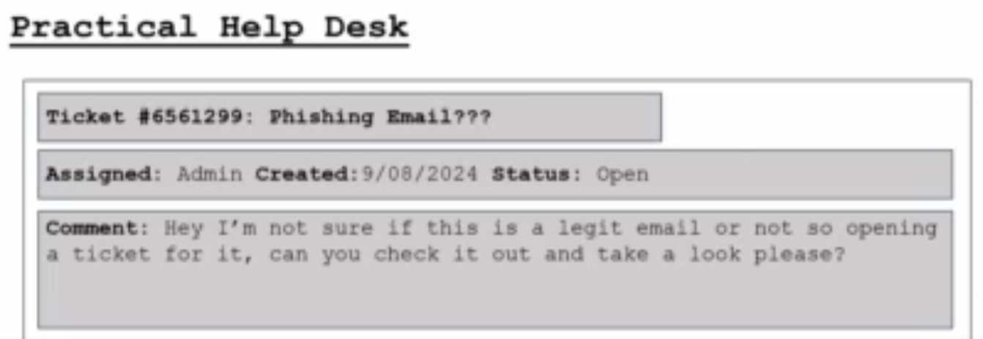

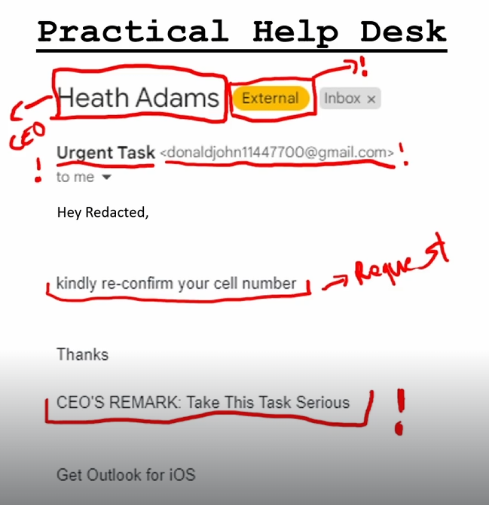

### Device Disposal

**Core Rule:** Deleting files or factory resetting is NOT secure. Data remains easily recoverable.

**Key Risks:**

* Data breaches & identity theft
* Corporate espionage
* Regulatory fines (GDPR, HIPAA)
* Reputational damage

**Secure Methods:**

1. **Data Wiping:** Use certified software to overwrite all data (for functional drives).
2. **Physical Destruction:** Shred, crush, or disintegrate drives (for SSDs or high-sensitivity data).

**Action Plan:**

* **Never** trash or recycle devices without data destruction.
* Use a certified e-waste recycler.
* Get a **Certificate of Destruction** for audit trails.

**Bottom Line:** Treat device disposal like destroying sensitive paper documents. Permanent data destruction is essential before recycling.

## 14. Soft Skills

## 15.Active Directory Lab

### What is Active Directory?

* **Definition**: Central database and service suite managing network resources
* **Primary Function**: Authentication, authorization, and resource management
* **Expanded Analogy**: Corporate Directory & Security System

**Corporate Directory Analogy**:

* **Phonebook Function**: Looks up users, computers, printers, shared folders
* **Security Badge System**:
  + Single Sign-On = One badge access to entire building
  + Permissions = Badge determines accessible areas
  + Central Management = Security office controls all access

**Why Use Active Directory?**

* **Centralized Management**: Administer all users/computers from one location
* **Single Sign-On (SSO)**: One login for all network resources
* **Security Enforcement**: Apply consistent policies across network
* **Resource Organization**: Logical structure for users and computers
* **Scalability**: Supports organizations of any size

**Physical Components (Tangible Elements)**

**Domain Controller (DC)**:

* Server running Active Directory Domain Services role
* Authenticates users and computers ("the bouncer")
* Hosts and replicates AD database

**AD Database (NTDS.dit)**:

* Physical file: C:\Windows\NTDS\ntds.dit
* Contains all domain objects and their attributes
* Master ledger of network resources

**Logical Components (Organizational Structure)**

**Domains**:

* Administrative and security boundary
* Logical grouping of network objects
* Unique namespace (e.g., LAB.local)
* Own set of policies and administrators

**Organizational Units (OUs)**:

* Containers within domains for organization
* Analogous to company departments
* Primary purposes:
  1. **Delegate Administration**: Grant limited admin rights
  2. **Apply Group Policy**: Target specific settings/software

**Non-container Objects**:

* Actual resources placed in domains/OUs
* "Leaves" on the directory tree
* Examples: Users, Computers, Groups, Printers

**Forest Structure & Relationships**

**Forest**:

* Top-level logical container in AD
* Complete security boundary
* Contains all domains, configuration, schema
* Typically one forest per organization

**Domain Tree**:

* Hierarchy of domains with contiguous namespace
* Example: company.com → europe.company.com

**Domain Trust**:

* Relationship allowing cross-domain authentication
* Automatic transitive trusts within a forest

Putting a win 11 and server 2025 into a NAT network , under same name

Rename win 11 as WS01

On the server making the manual ipv4 to ipconfig (ip) as done on the cmd

And preferred dns as 127.0.0.1

On the win 11

Access work or school ->connect

Join a domain ( LAB.local )

Administrator and password

Next and restart ,

other user and sign in

Back in the Server in the server manager we can see under active directory users and computers - WS01 under Computers

### Organizational Management

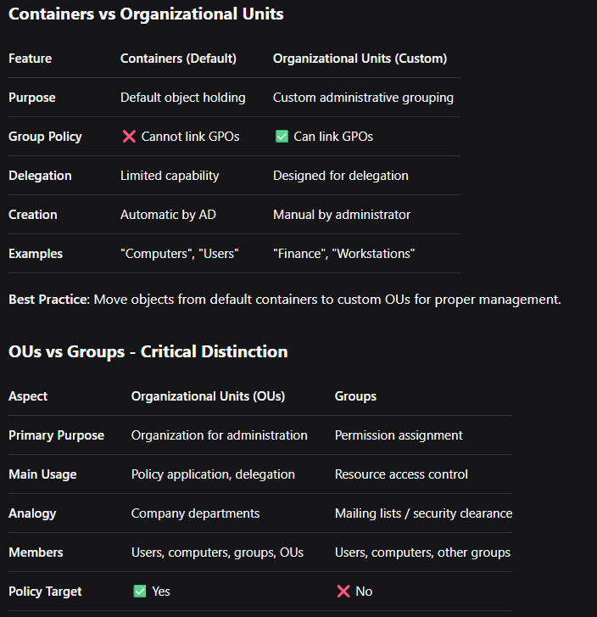

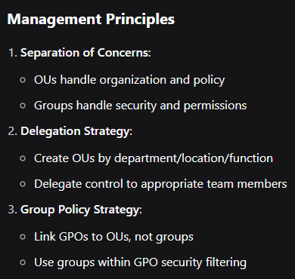

### Group Policy Objects

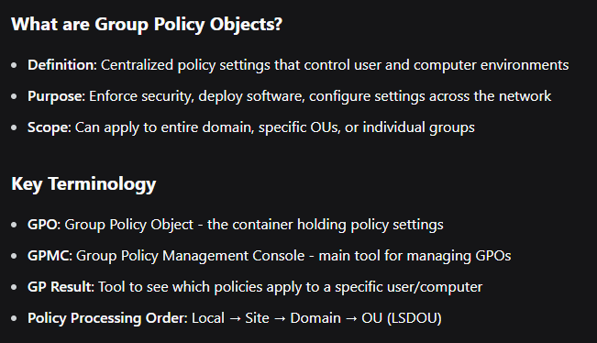

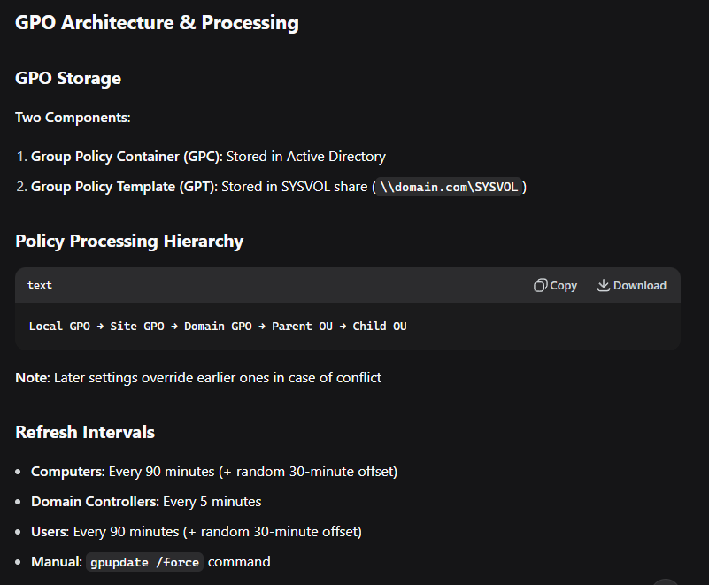

### Ticket Interrupt

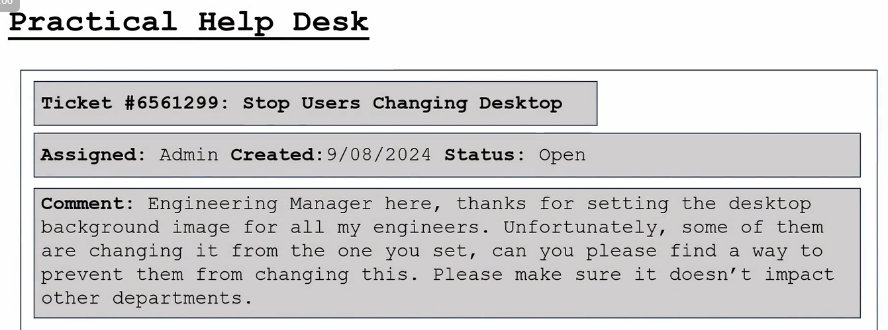

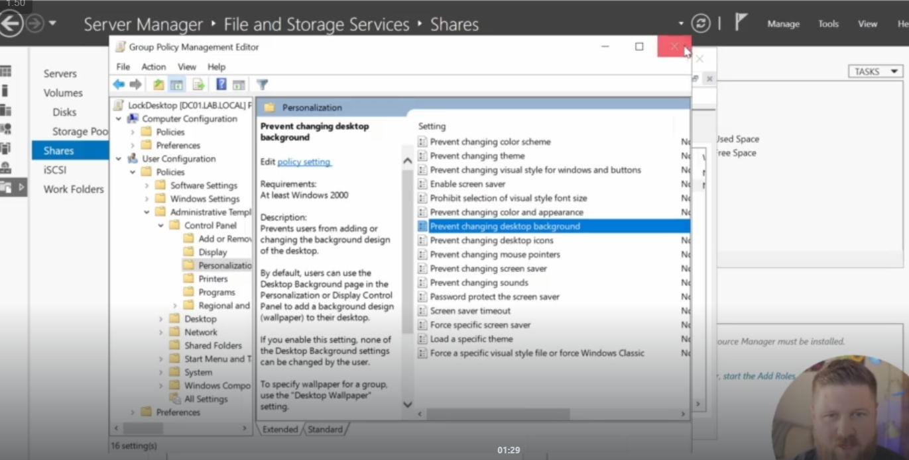

### Intro to Powershell

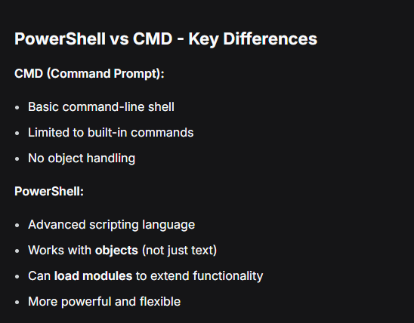

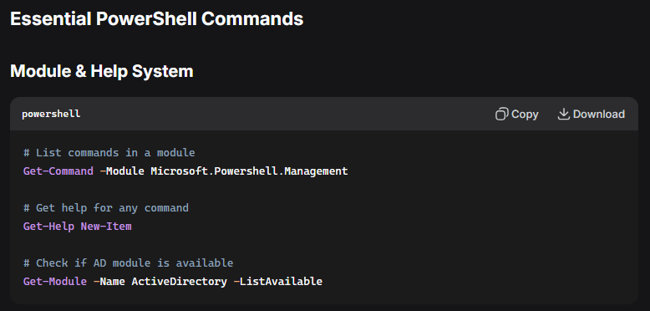

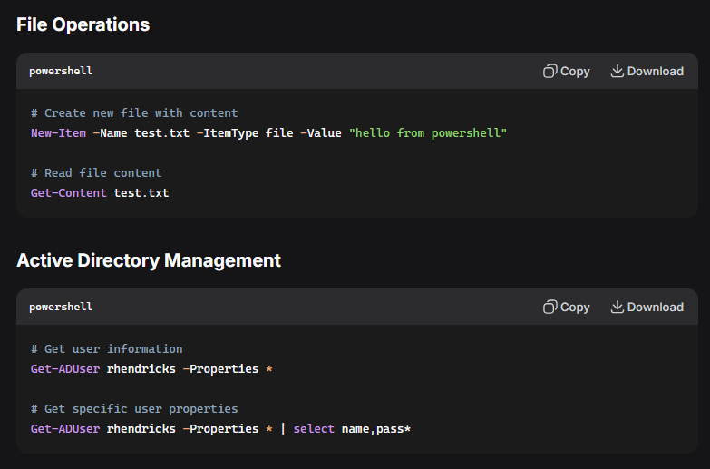

### Automating Tasks with PowerShell

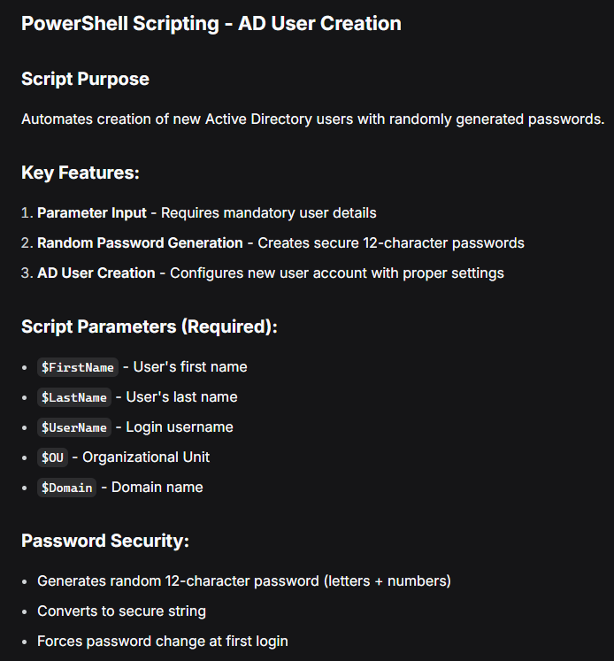

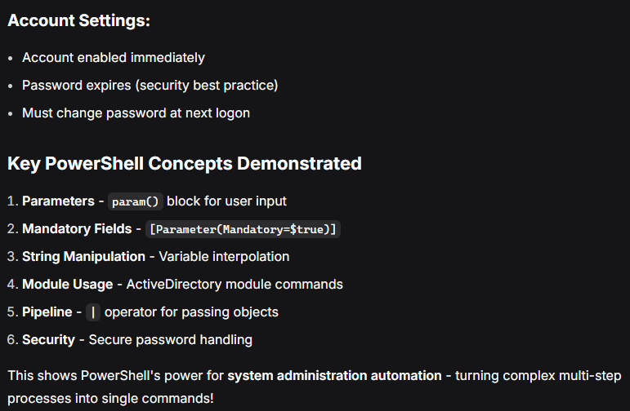

### Resetting AD Passwords

Using domain controller -server manager and powershell

